F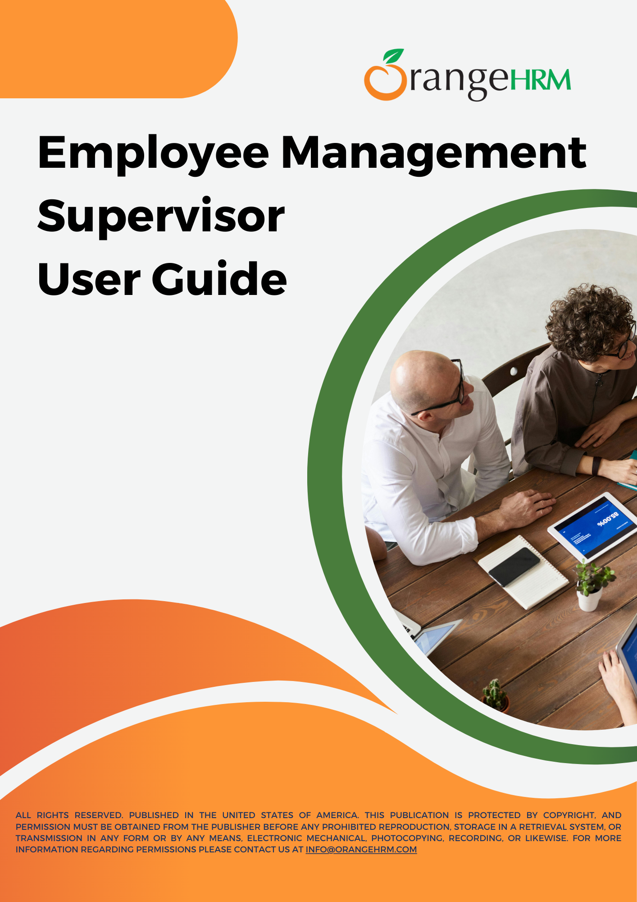

**Table of Contents**

**Introduction 2**

**Login 4**

Employee Management 5

**How to access the Employee Profiles 15**

Employee List 15

How to access Employee profiles 18

**Dashboard and Menu Options 21**

My Widget Configuration 22

My Actions 23

Quick Access 24

News and Documents 27

Preferences 29

Organization Chart 31

Directory 32

**Reports and Analytics 33**

How to View Reports using OrangeHRM 33

**RESOURCES 34**

**Tables**

Table 1: Tabs Under More Section 13

Table 2: Filter fields 18

# 

**Table of Figures**

Image 1: Login Panel 4

Image 2: Personal Details tab 5

Image 3: Profile Picture 6

Image 4: Configure Profile Picture 7

Image 5: Job tab 8

Image 6: Salary tab 9

Image 7:Contact Details tab 10

Image 8:Social Media Details 11

Image 9: More 12

Image 10: Add attachments 14

Image 11: Employee List 15

Image 12: Filter Employee 16

Image 13: Employee Profile 18

Image 14: Edit Personal Details 19

Image 15: Additional Information 20

Image 16: Attachments 20

Image 17: Dashboard 21

Image 18: My Widget Configuration 22

Image 19: My Actions 23

Image 20: Quick Actions 24

Image 21: My shortcuts 25

Image 22: Add shortcut 25

Image 23: Quick access Shortcut 26

Image 24: Quick Access Widget 26

Image 25: News and Documents widget 27

Image 26: How to Acknowledge 28

Image 27: My Preferences 30

Image 28: Organization Chart 31

Image 29: Directory 32

Image 30: View Reports 33

# **Introduction**

This document serves as a guide for Supervisors to help them understand how to use the licensed modules and gain a deeper insight into the system's functionalities and capabilities. Step-by-step

Instructions and images are also included to assist users in accessing and navigating the system.

This user guide is intended for Supervisors in the Organization. It covers the following modules:

* Employee Management
  + Employee List
  + My info
  + Directory
  + Buzz
  + Announcements
  + Organization Chart
  + Competencies
  + More
  + Dashboard and menu options
* Reports and Analytics
  + How to view reports using OrangeHRM

# **Login**

Users can use the standard login screen to log into the OrangeHRM system.

**Step 1** – Enter your OrangeHRM URL address in the browser. The OrangeHRM Login page appears as below. In the login panel, enter the username and password and click ‘Login’.

( If you have single sign-on enabled then you can use the SSO to log in to the system.)

OrangeHRM URL - < Enter your instance URL here >

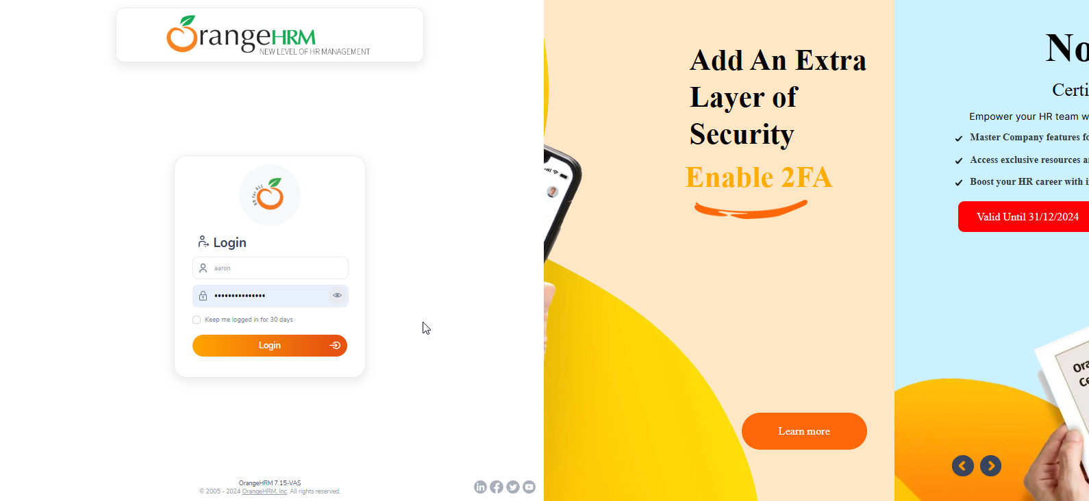

#### Image 1: Login Panel

## **Employee Management**

### **My info**

My info tab is where you will have access to view the information that is added to the system.

### **Personal Details**

The Employee's Personal Details is where the data can be viewed, edited, and stored. An employee's details can be accessed through the “My Info” tab from the main navigation panel.

Upon clicking on the My Info tab, your profile will appear as below.

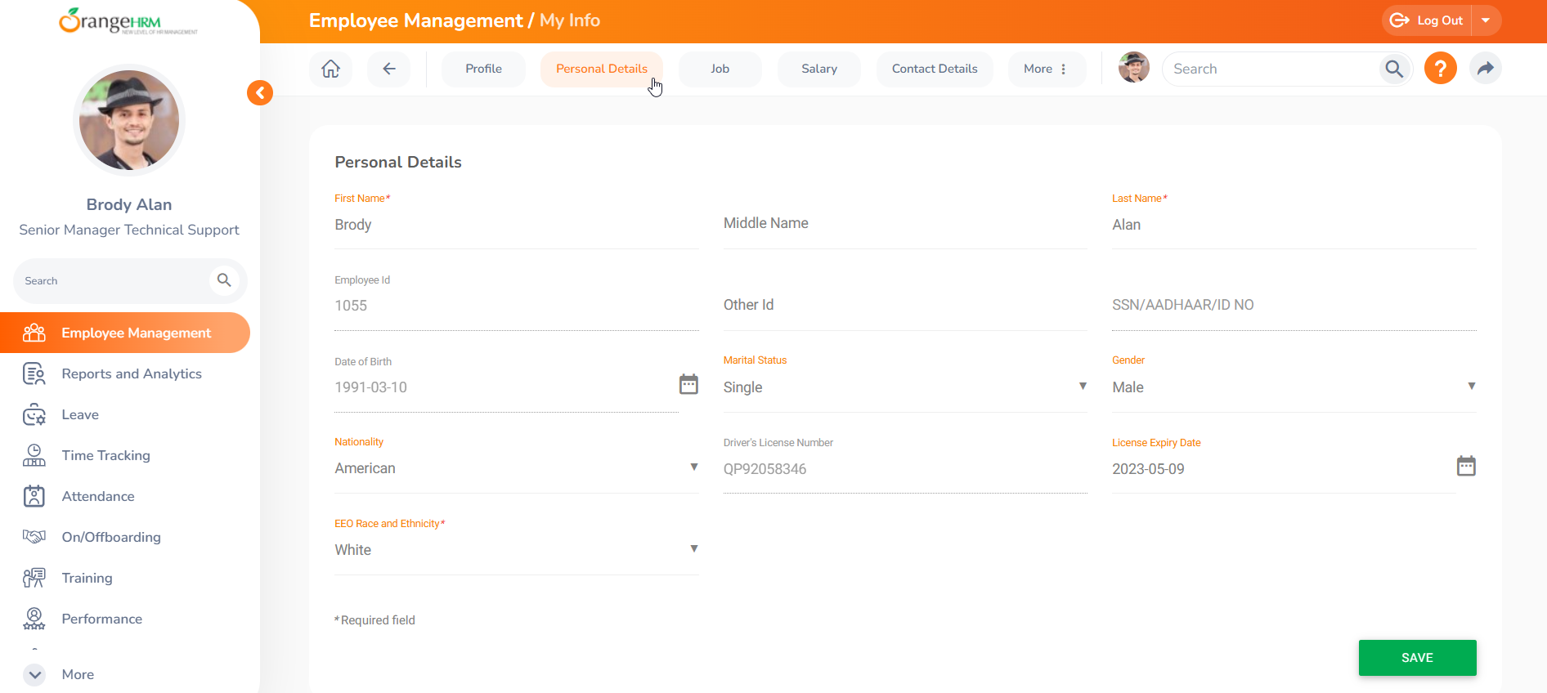

#### Image 2: Personal Details tab

The Employee Profile is subdivided into five distinct tabs:

* Personal Details
* Job
* Salary
* Contact details
* Social media details
* More

### **Profile**

To change the employee profile picture, go to Profile, and in the "About" section, you can change your profile picture. Please refer to the following screenshot.

#### 

#### Image 3: Profile Picture

A Modal window would appear as below. You can now click on the photograph and browse to select the photographic image you wish to use.

#### 

#### Image 4: Configure Profile Picture

Once you select your new picture, you have to scale your image so the profile picture contains the part of the image that you want. When you have completed scaling and cropping the image, you can go ahead and save it as your profile picture.

### 

### 

### **Job**

This tab contains all the information about your Job. Only HR or admins can update this information.

#### 

#### Image 5: Job tab

### 

### **Salary**

The Salary tab contains your Salary information and any changes to the Salary data are tracked under the Salary History Section in the Salary tab.

#### 

#### Image 6: Salary tab

### 

### **Contact Details**

The Contact Details tab includes information such as mobile numbers, addresses, and email addresses.

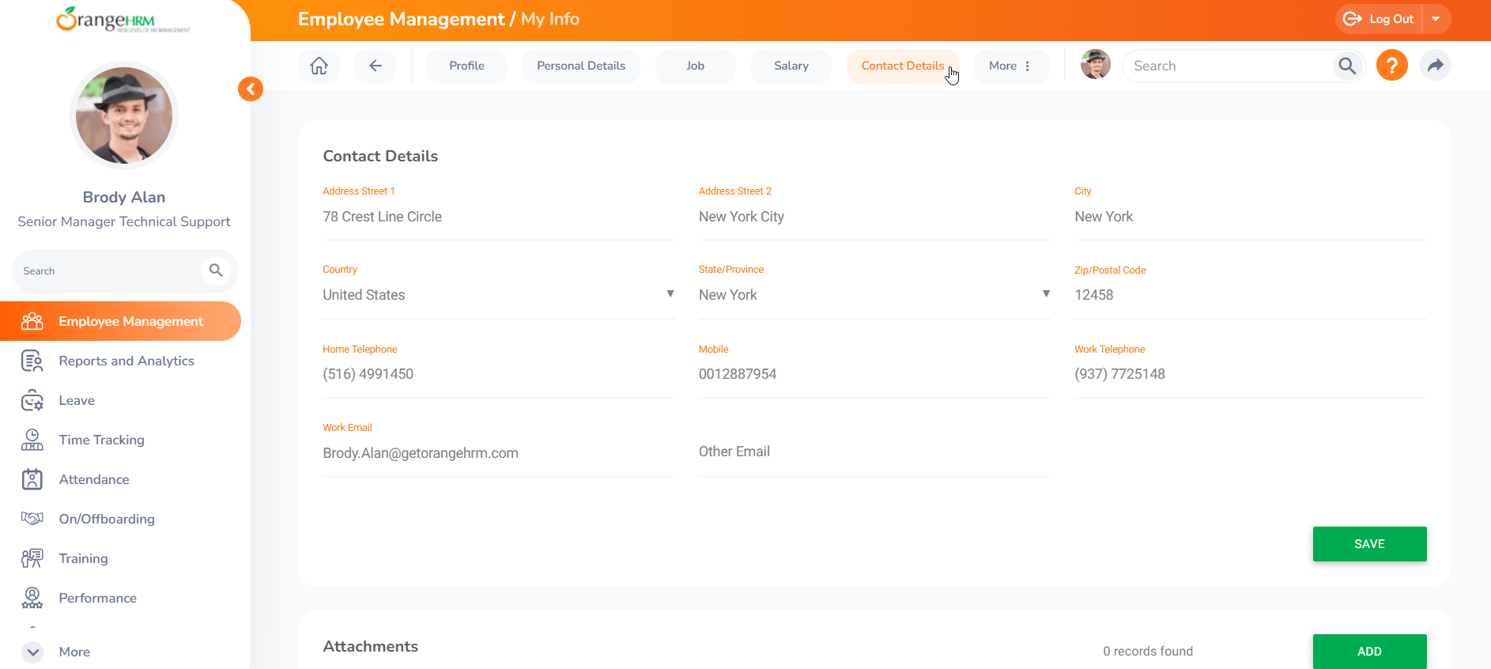

#### Image 7:Contact Details tab

### 

### **Social Media Details**

You can add your social media details, such as Twitter, LinkedIn, Facebook, etc.

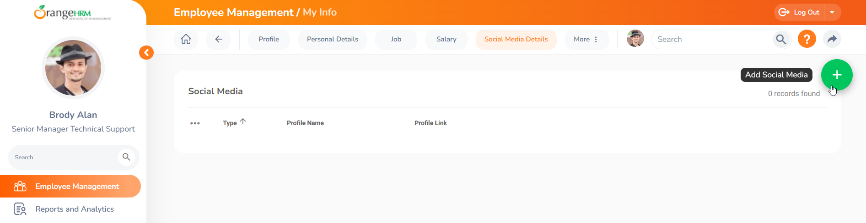

#### Image 8:Social Media Details

### **More**

The More tab contains additional PIM tabs about an employee's profile. These tabs can be used to record additional important and useful employee information. Default and Custom PIM tabs can be found in the More tab. The More tab contains the following default PIM tabs.

#### 

#### Image 9: More

| **More Section** | **Description** | **Access for Supervisor** | **Access for Self** |
| --- | --- | --- | --- |
| Emergency Contacts | This section allows you to input and manage contact information for individuals to be reached in case of an emergency. | View/Edit | View/Edit |
| Dependents | Maintains an employee's dependents information | View/Edit | View/Edit |
| Immigration | Employees' immigration records are added here in this tab. Any passport VISA-related information and documents can be added and uploaded in this tab. | View/Edit | View/Edit |
| Report to | Employees can view their assigned Supervisor and subordinates on this screen. Supervisors can view their subordinates' reports. | View | View |
| Qualifications | Employee's qualifications include work experience, education, skills, languages, and licenses. Employees can add or update the information on this screen. Supervisors can view the information if needed. | View/Edit | View/Edit |
| Memberships | If an employee attains a membership that can be added and viewed in this tab. | View/Edit | View/Edit |
| Technical Skills | Employees can add their Technical Skills. Supervisors can view their employees' Technical Skills. | View | View/ Edit |
| Benefits Information | Employees can add their Benefits Information. Supervisors can view their employees’ Benefits Information. | View | View/ Edit |

##### 

##### Table 1: Tabs Under More Section

**Uploading Attachments under My Info Tab**

In each Employee Profile, several tabs allow employees to add an attachment.

For example, My info > Personal Details > Attachment option.

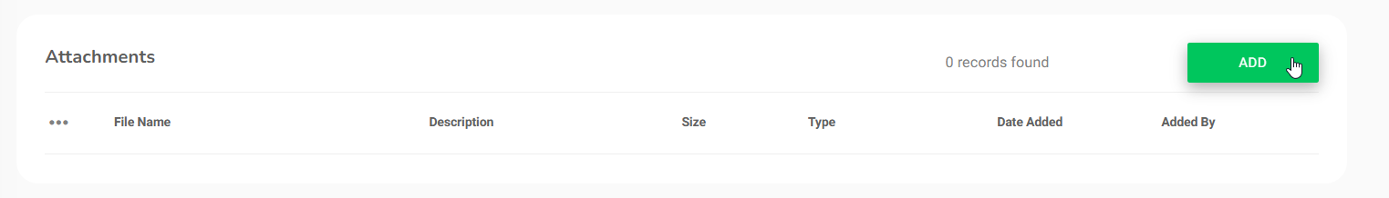

#### Image 10: Add attachments

## 

## 

## 

## 

## 

## **How to access the Employee Profiles**

## **Employee List**

To access your subordinate's details navigate to Employee Management and select the Employee list.

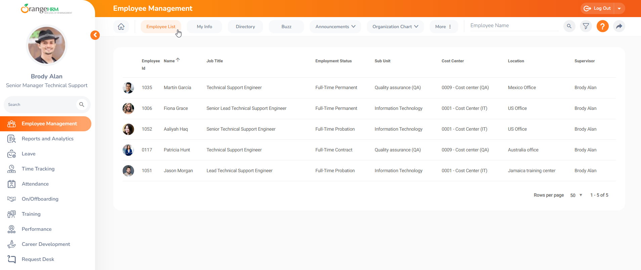

#### Image 11: Employee List

### 

### 

### 

### 

### 

### **Filter Employee List**

In the Employee List, click the ‘Filter’ icon in the top-right corner. This will open a popup window as shown below.

#### 

#### Image 12: Filter Employee

| **Filter** | **Description** |
| --- | --- |
| Employee Name | Filter by employee name |
| Employee ID | Filter by Employee ID |
| Employment Status | Filter by Employment Status |
| Supervisor name | Gives a list of employees who are subordinates of the selected supervisor. |
| Job Title | Filter by the Job Title |
| Sub Unit | Filter by the Department |
| Include | Search current or past employees. Or both. |
| Location | Filter by the location where they work |
| Cost Center | Filter by the Cost Center |
| Make Filter Default | Save the above filter selection as the default search every time the user accesses the employee list. |

##### 

##### Table 2: Filter fields

## **How to access Employee profiles**

Once you have filtered the required set of Employees select the relevant profile. Once you have selected the Employee profile you can see the following details similar to the tabs that were shown in your profile you can see the same but with the supervisor access configured by the HR Administrator in your Organization.

* Profile
* Personal Details
* Job details
* Salary Details, etc

#### 

#### Image 13: Employee Profile

### 

### 

### 

### 

### 

### 

### 

### **Personal Details**

The "Personal Details" section contains all the employees’ personal information. All company employees have access to view this information; however, Supervisors possess the authorization to modify specifics like Employee Names, Gender, and other personal details recorded within the system. Once the changes are done click on ‘Save’ to save the changes.

#### 

#### Image 14: Edit Personal Details

In addition to personal details, can edit and update other relevant information for the selected employee.

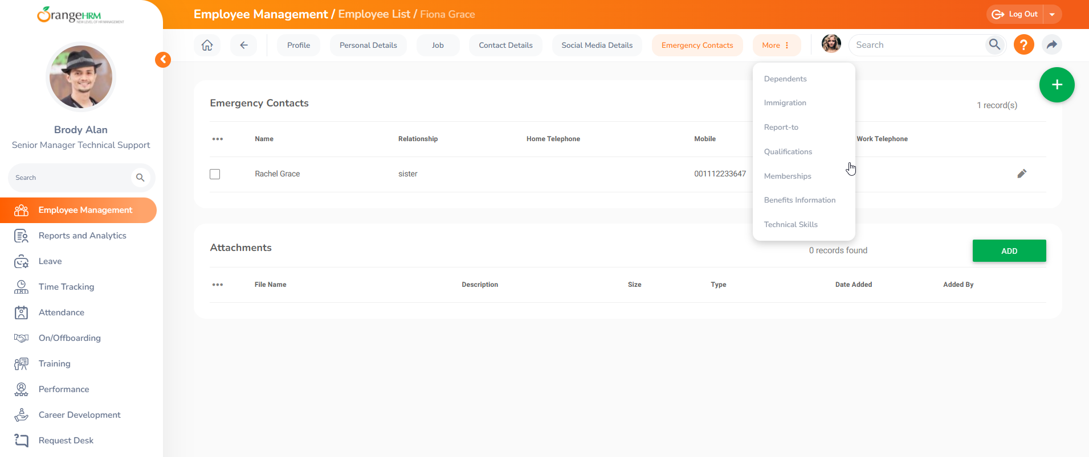

#### Image 15: Additional Information

Supervisors also have access to view or add any attachments under employee personal details and can add attachments by clicking the add button.

#### 

#### Image 16: Attachments

# **Dashboard and Menu Options**

Once you successfully log into the system, you will be directed to the Dashboard screen by default. Alternatively, you can quickly access the dashboard screen at any time by clicking on the Home icon.

The OrangeHRM Dashboard comprises several configurable widgets. The ‘My Actions’ widget allows you to easily see the actions that you may need to perform.

#### 

#### Image 17: Dashboard

## 

## **My Widget Configuration**

By clicking on the configuration icon, you can see the widgets that are available to you. From here you can either enable or disable the widgets which you would like to see on your dashboard as per your preference.

#### 

#### Image 18: My Widget Configuration

## 

## **My Actions**

The “My Actions” widget will display any pending tasks that you need to take action on. For example: When appraisals have been created for you by HR, within the “My Actions” widget, that specific notification is displayed.

If there are specific items within the “My Actions” Widget that you are not interested in seeing, simply click the configuration icon on top of this widget and you can disable them from here as follows:

#### 

#### Image 19: My Actions

## 

## 

## 

## **Quick Access**

Through the ‘quick access’ widget, you can immediately access all your saved shortcut screens. All your saved shortcuts will be displayed here and you can click each listed shortcut to view that specific screen. The specific filters that you've specified for the employee list will be remembered as part of the shortcut. This is very useful if you regularly want to return to the employee list with different views.

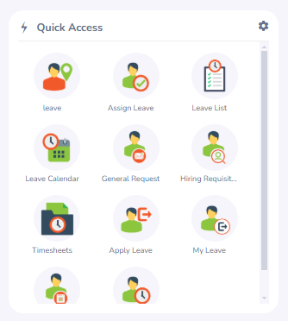

#### Image 20: Quick Actions

As an example, if you wish to make the employee list screen a shortcut, please refer to the following screenshot and follow Step 1 below.

Step 1: Go to Employee Management and set the filters in the employee list based on certain criteria. Click the Shortcut icon in your dashboard.

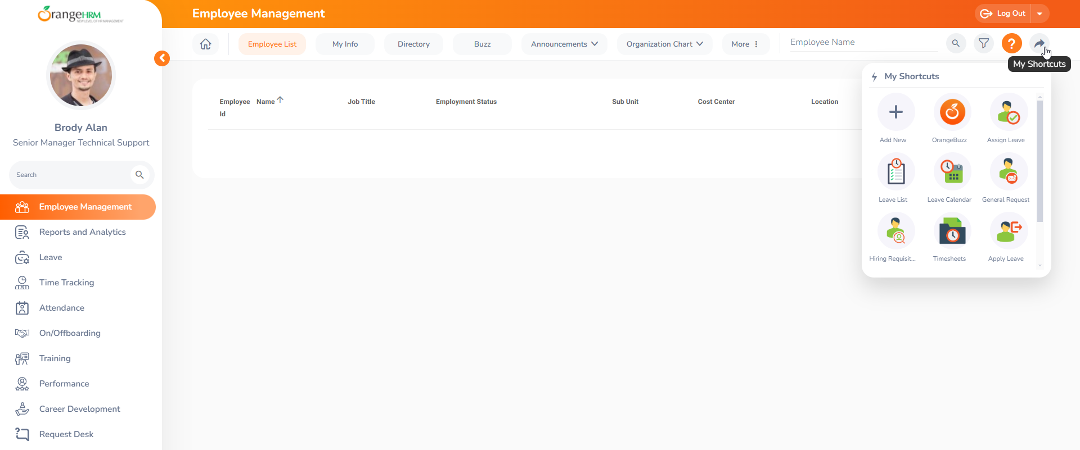

#### Image 21: My shortcuts

Then click "My Shortcuts" and in the popup window click the add button and enter the name.

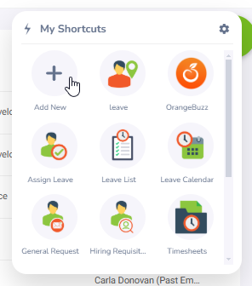

#### Image 22: Add shortcut

#### 

Then add the name you want to display.

#### 

#### Image 23: Quick access Shortcut

The newly added shortcut will appear as shown below

#### 

#### Image 24: Quick Access Widget

## **News and Documents**

All the published news and documents will be displayed in these widgets The HR team can publish new HR policies, Leave policies, or other Organizational policies in the OrangeHRM system and these can be easily accessed and viewed via the ‘Latest News’ and ‘Latest Documents’ widgets., So, you can access the News and Documents screen by clicking on the Home icon and viewing via these widgets or alternatively by going to the Menu on the left.

This useful feature also allows organizations to keep track of whether published News/Documents have been read or not, by requesting Acknowledgement from the intended audience.

#### 

#### Image 25: News and Documents widget

Where HR has requested acknowledgment, when you click on an individual news or document item from the widget, there will be a checkbox directly beneath the news/document article allowing you to acknowledge whether you have read it or not.

Step 1 - Once clicked, it will ask you to confirm. Click the “Yes, Acknowledge” button.

#### 

#### Image 26: How to Acknowledge

## 

## **Preferences**

The Preferences feature of OrangeHRM allows you to configure the language of the system according to the preferred language of the user.

The list of supported languages is:

* English
* Chinese (Simplified Han)
* Chinese (Traditional Han)
* French
* German
* Italian
* Spanish
* Hungarian
* Russian
* Thai

To access this feature, go to My Settings > Language & Date Preference.

Users can select their preferred language and date format which will then be applied to the system upon clicking the ‘Save’ button.

#### 

#### Image 27: My Preferences

## 

## 

## **Organization Chart**

The organization chart provides a graphical representation of your employee hierarchy. Any employee can view the full hierarchy from this screen and print it if they wish.

To navigate to the Org chart, go to Employee Management > Organization Chart > View

#### 

#### Image 28: Organization Chart

## 

## 

## 

## **Directory**

The corporate directory is the section where users can view public information relating to employees such as employee name, job title, subunits, location, or work Email address.

The Corporate Directory can be accessed by clicking, Employee Management > Directory

#### 

#### Image 29: Directory

# **Reports and Analytics**

In the Reports and Analytics section, you can access reports that contain details about your subordinates, subject to the access privileges granted by your HR Administrator.

## **How to View Reports using OrangeHRM**

To view a report, navigate to the Reports and Analytics Module and select the report.

#### 

#### Image 30: View Reports

# **RESOURCES**

This user guide has been designed for OrangeHRM and for any queries use the [OrangeHRM Help Portal](https://help.orangehrm.com/hc/en-us) or for any support matters drop an email to [goldsupport@orangehrm.com](mailto:goldsupport@orangehrm.com)

_END_