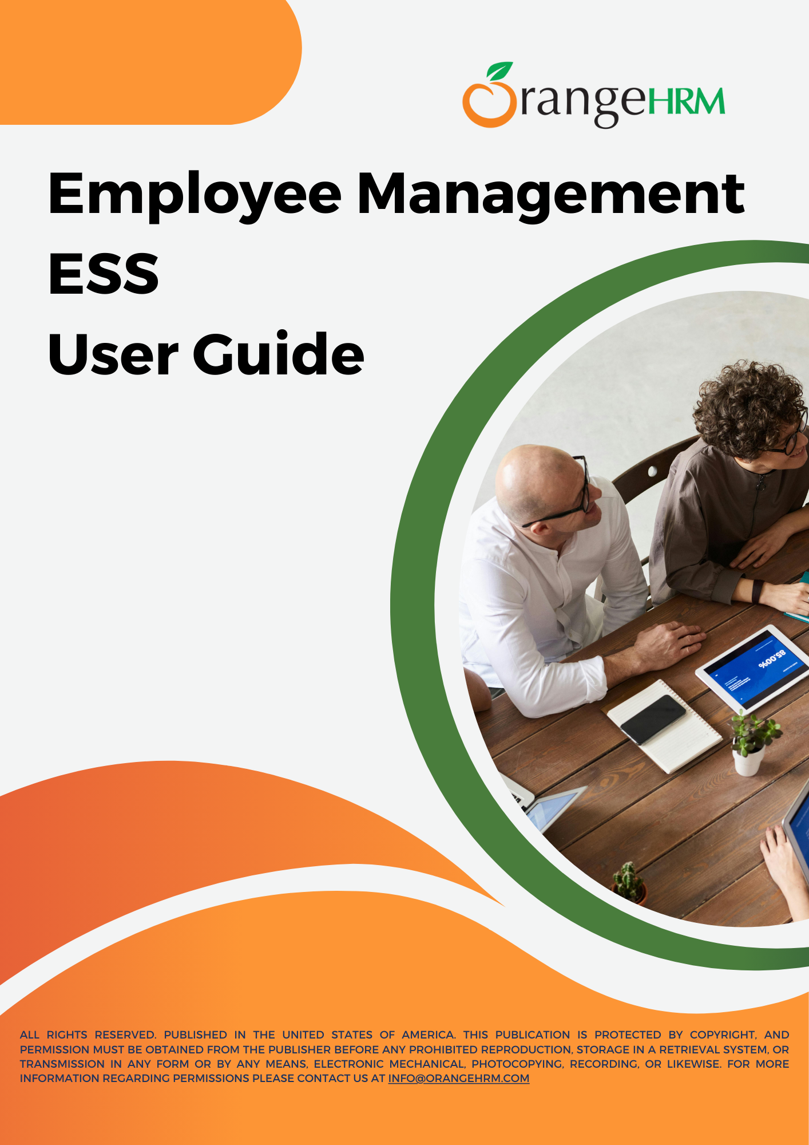

**Table of Contents**

**Introduction 4**

**Login 5**

**Employee Management 6**

1. My info 6

1. Profile 6

2. Personal Details 9

3. Job 10

4. Salary 13

5. More 14

2. Directory 16

3. Buzz 17

4. Announcements 18

5. Organization Chart 19

6. Assets 20

7. Dashboard and Menu options 21

1. My widget configuration 22

2. My Actions 23

3. My Shortcuts 26

4. Quick Access 27

**My Settings 28**

1. Change Password 30

2. Language and Date Preference 31

**Resources 32**

**Table of Figures**

Image 1: Login Panel 5

Image 2: Profile 6

Image 3: Profile Picture 7

Image 4: Configure Profile Picture 8

Image 5: View Personal Details 9

Image 6: Upload attachments 9

Image 7: View the Job tab 10

Image 8: Select the snapshot view 11

Image 9: Snapshot view 11

Image 10: Exit snapshot view 12

Image 11: View the Salary tab 13

Image 12: View More 14

Table 1: Tabs under the More section 15

Image 13: Corporate Directory 16

Image 14: Buzz widget 17

Image 15: News & Documents Widget 18

Image 16: News & Documents acknowledge 18

Image 17: Organization Chart View 19

Image 18: View Assets 20

Image 19: OrangeHRM Dashboard 21

Image 20: My Widget Configuration 22

Image 21: My Action Widget 23

Image 22: My Action summary view & individual view 24

Image 23: My Action Configurations view 25

Image 24: My Shortcuts Widget 26

Image 25: Quick Access widget 27

Image 26: Setting icon 28

Image 27: Navigation My Settings 28

Image 28: About View 29

Image 29: Change Password 30

Image 30: Language and Date Preference 31

# **Introduction**

The purpose of this document is to serve as a guide for employees to help them understand how to use the licensed modules and gain a deeper insight into the system's functionalities and capabilities. Step-by-step instructions and images are also included to assist users in accessing and navigating the system.

This user guide is intended for ESS in OrangeHRM and applies to the Phase 1 rollout of the platform. It covers the following modules:

* Employee Management
  + My info
  + Directory
  + Buzz
  + Announcements
  + Organization Chart
  + Assets
  + Dashboard and menu options
* My Settings

# **Login**

The Employees can use the standard login screen to log into the OrangeHRM system.

**Step 1** –Enter the OrangeHRM URL address in the browser. The OrangeHRM Login page appears as below:

OrangeHRM URL - < Enter your instance URL here >

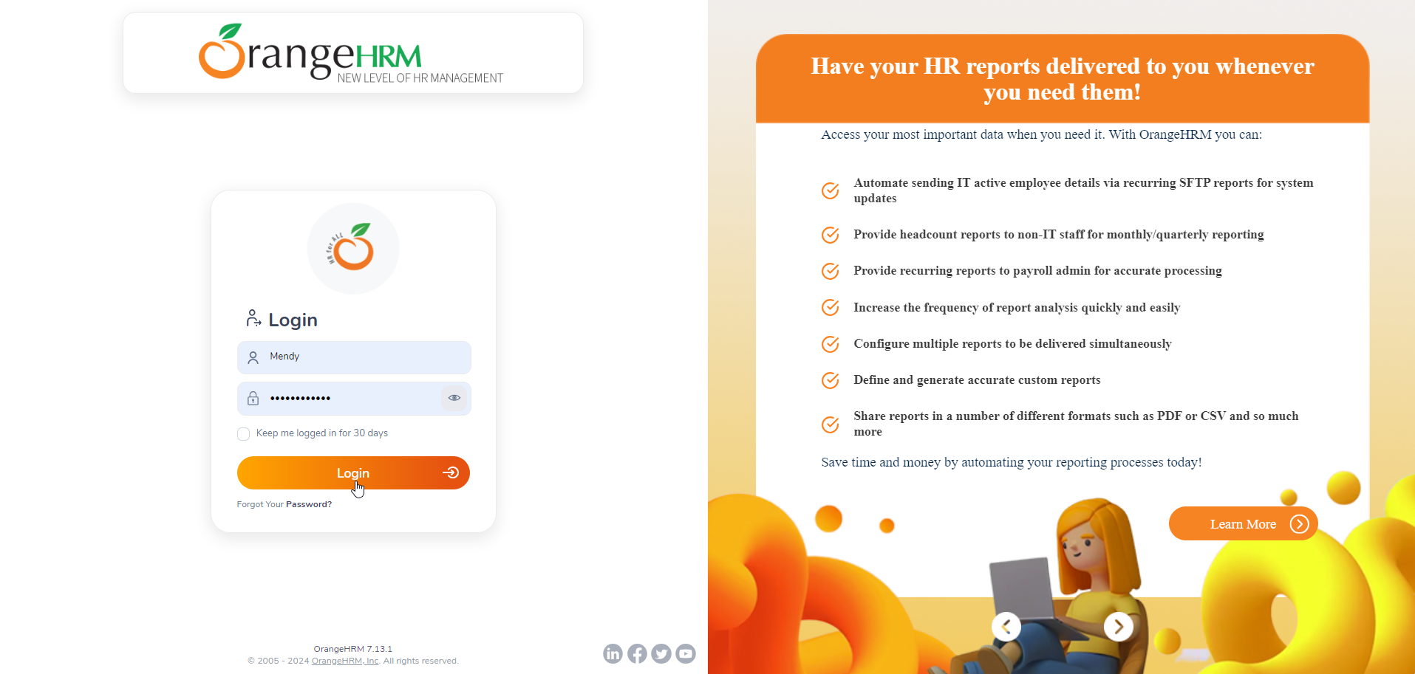

##### Image 1: Login Panel

**Step 2** - In the login panel, enter the username and password and click ‘Login’. ( If you have single sign-on enabled then you can use the SSO to log in to the system.)

## **Employee Management**

### **My info**

My info tab is where you will have access to view the information that is added to the system. First, you will be presented with the My Info Dashboard.

#### **Profile**

The Employee Profile is where an employee's data can be viewed, edited, and stored. An employee's profile can be accessed through the “Profile” tab in the main navigation panel.

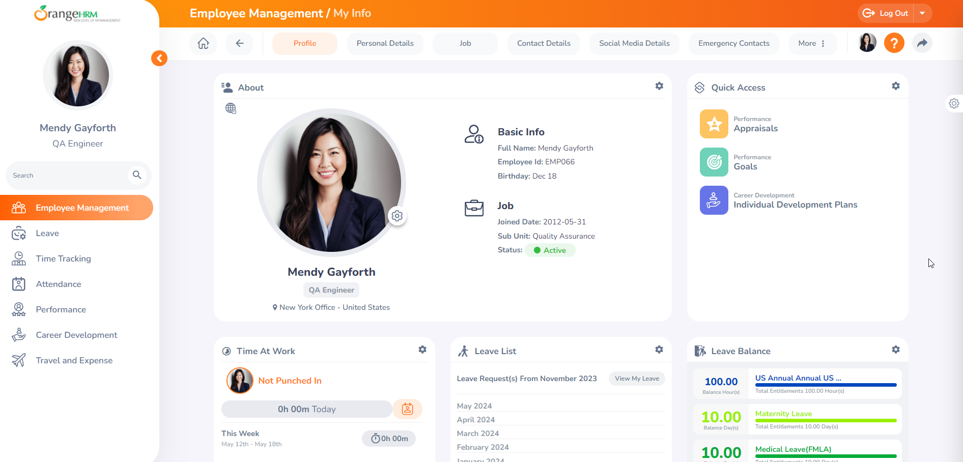

##### Image 2: Profile

The Employee Profile is categorized into the following tabs by default:

* Personal Details
* Job
* Salary
* Contact Details
* Social media details
* Emergency Contacts
* More

**Profile Picture**

To change the employee profile picture, click the configuration icon and upload the profile picture. If you do not have access to update the profile picture please inform the HR manager to update the profile pictures on behalf of you.

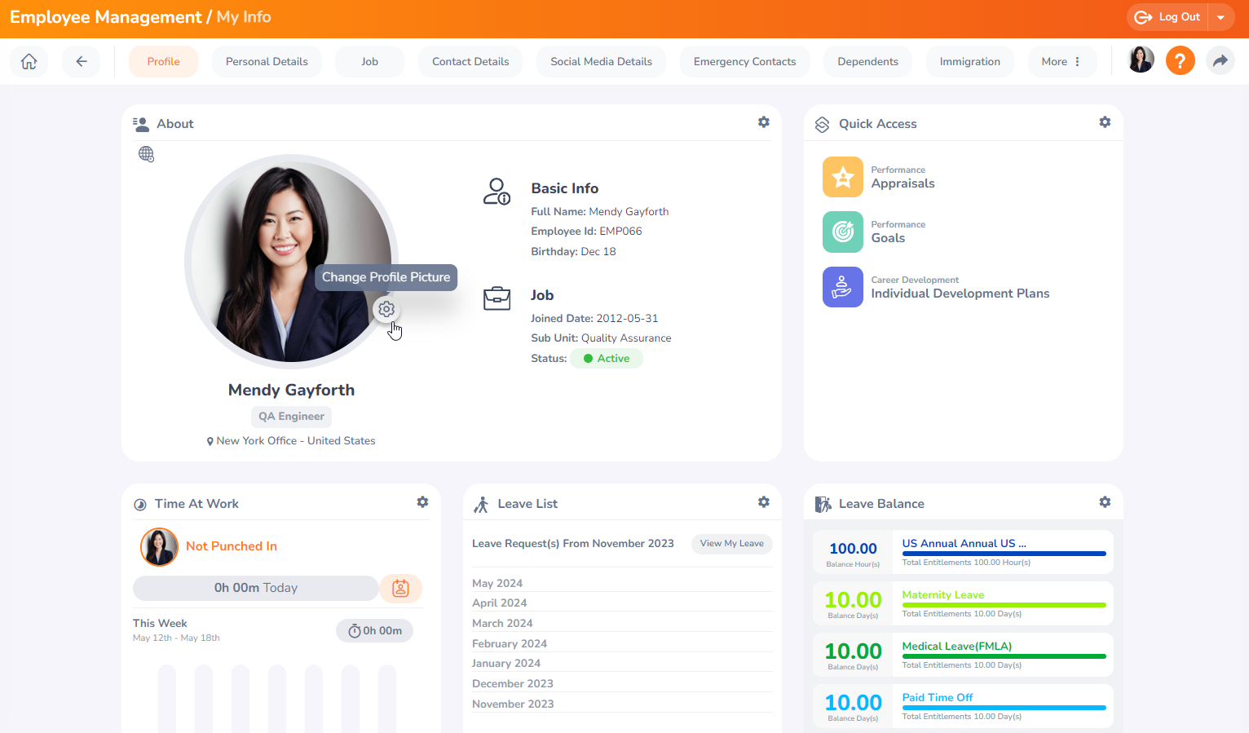

##### Image 3: Profile Picture

A modal window appears as below. The user can click on the photograph and browse to select a suitable photo.

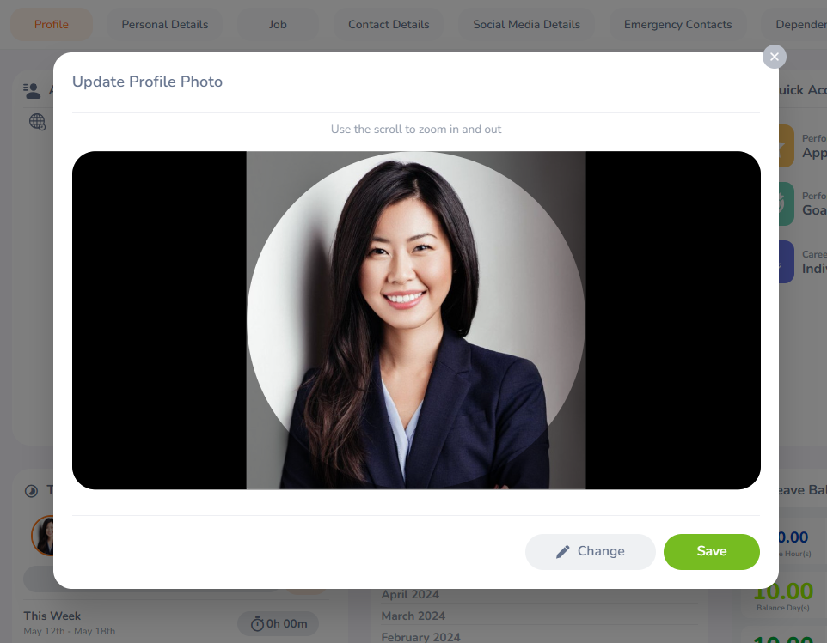

##### Image 4: Configure Profile Picture

Once the new picture is selected, the user has to scale the image so the profile picture contains the desired part of the image. After completing the scaling and cropping of the image, the user can save it as a profile picture.

#### **Personal Details**

This tab contains all personal information and data. Some of the data can be edited here (name, other ID, gender, Marital status, Nationality, and license expiry date). However, certain information, such as Employee ID and Date of Birth, cannot be edited by the user or the line manager; only HR can update this information. If any incorrect information is found, contact the HR team immediately.

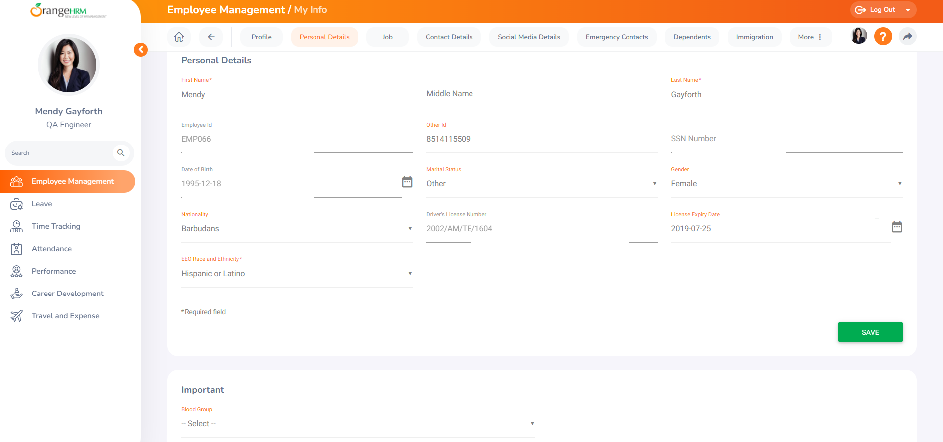

##### Image 5: View Personal Details

**Uploading Attachments under My Info Tab**

In each Employee Profile, there are several tabs that allow employees to add an attachment.

For example, **My info > Personal Details > Attachment** option. The user can add an attachment of up to 5MB in size.

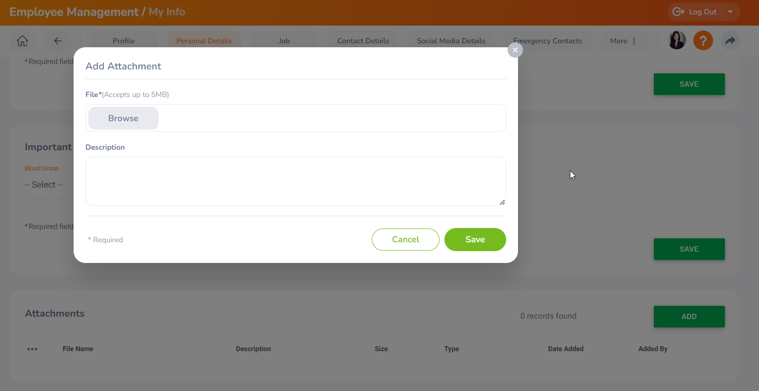

##### Image 6: Upload attachments

#### **Job**

This tab contains all information about the Job details. Only HR or admins can update this information. The job-related changes are tracked under the job history section.

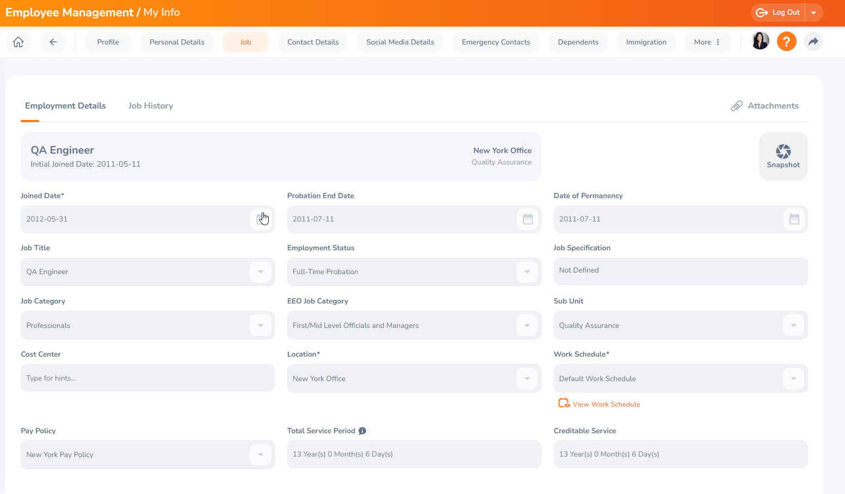

##### Image 7: View the Job tab

If you want to check a Snapshot view of your job data for a certain date select the snapshot view as shown below.

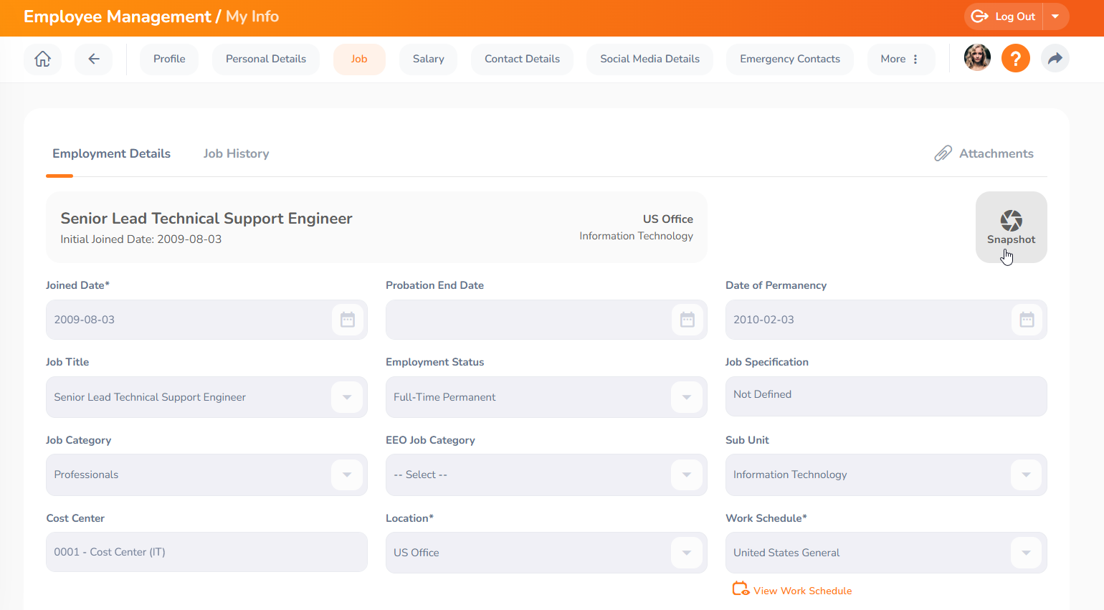

##### Image 8: Select the snapshot view

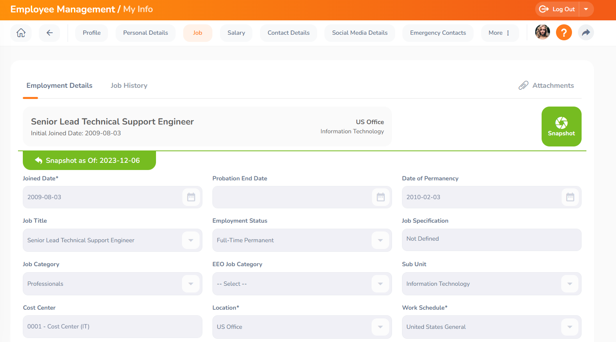

##### Image 9: Snapshot view

To exit from the snapshot view click the exit snapshot view as shown below.

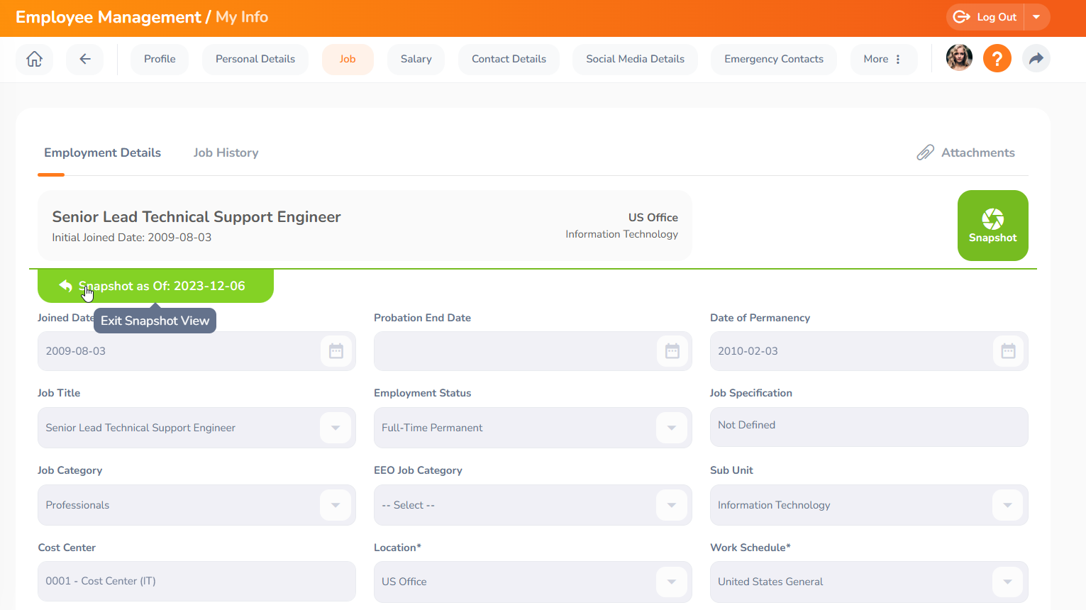

##### Image 10: Exit snapshot view

#### **Salary**

The Salary tab contains the employee's salary information and data. All updates, modifications, and transactions that have been made to an employee's salary-specific information are tracked and can be viewed via the Salary History section in the Salary tab.

Only HR and admins can see the salary information within the profile.

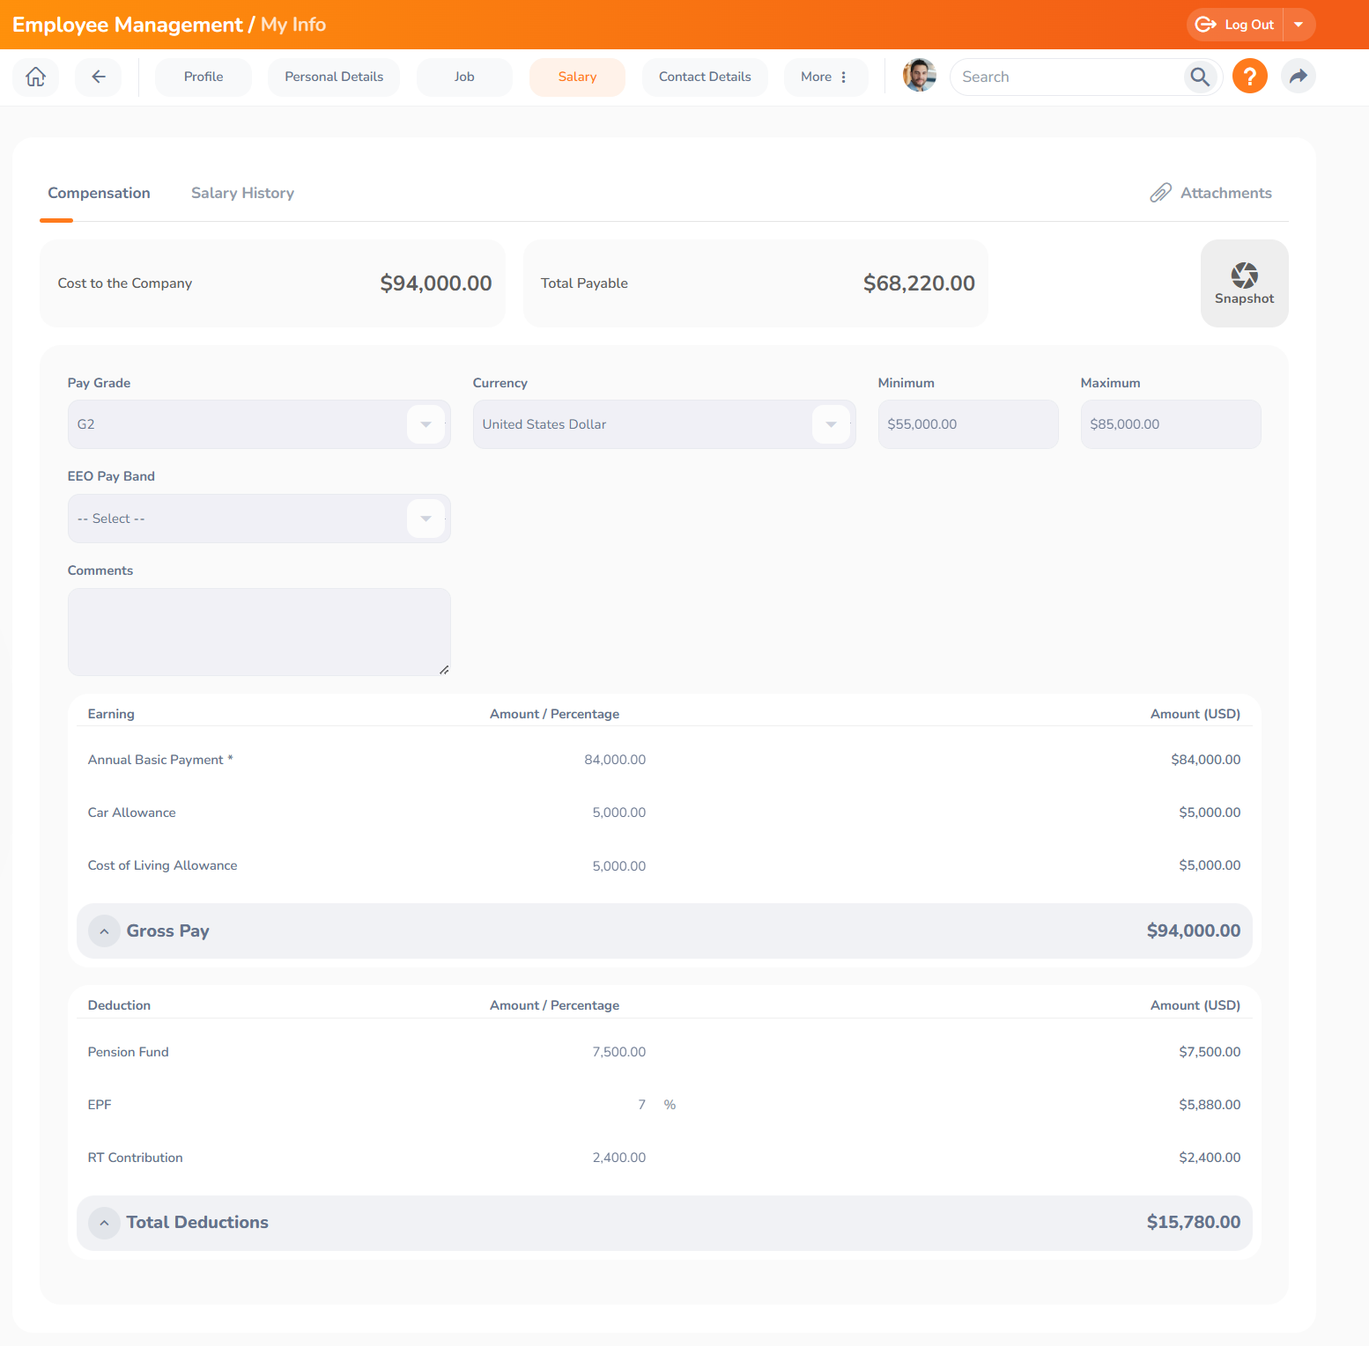

##### Image 11: View the Salary tab

#### **More**

The More tab contains additional Employee Management tabs about an employee's profile. These tabs can be used to record additional important and useful employee information. Default and Custom Employee Management tabs can be found in the More tab. The More tab contains the following default Employee Management tabs for OrangeHRM.

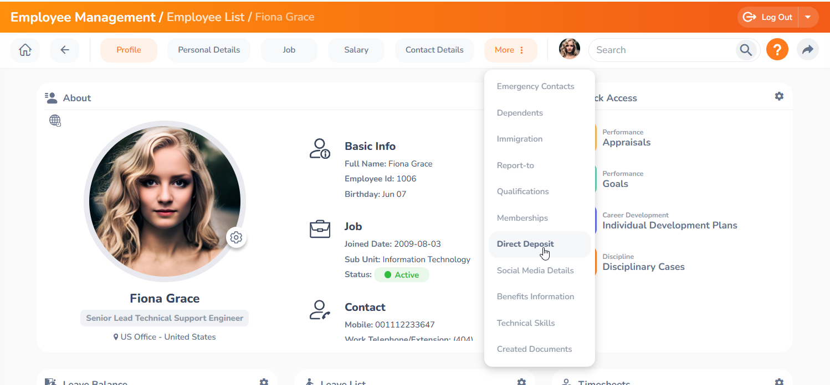

##### Image 12: View More

| **More Section** | **Description** | **Access Privileges** |
| --- | --- | --- |
| Contact Details | You can maintain your contact details in this tab | View/Edit |
| Social Media Details | You can maintain your Social Media Details in this tab | View/Edit |
| Emergency Contacts | You can maintain your Emergency Contacts in this tab | View/Edit |
| Dependents | You can maintain your dependents in this tab | View/Edit |
| Immigration | You can maintain your Immigration in this tab | View/Edit |
| Report to | You can view your reporting managers' names in this tab | View |
| Qualifications | You can maintain your work experience, education, skills, languages, and licenses. | View/Edit |
| Memberships | You can maintain your memberships in this tab | View/Edit |
| Direct Deposit | You can view your bank details in this tab | View |

##### Table 1: Tabs under the More section

##### 

### **Directory**

The corporate directory is the section where users can view public information relating to employees such as employee name, job title, subunits, location, or work Email address.

The Corporate Directory can be accessed by clicking, **Employee Management > Directory**

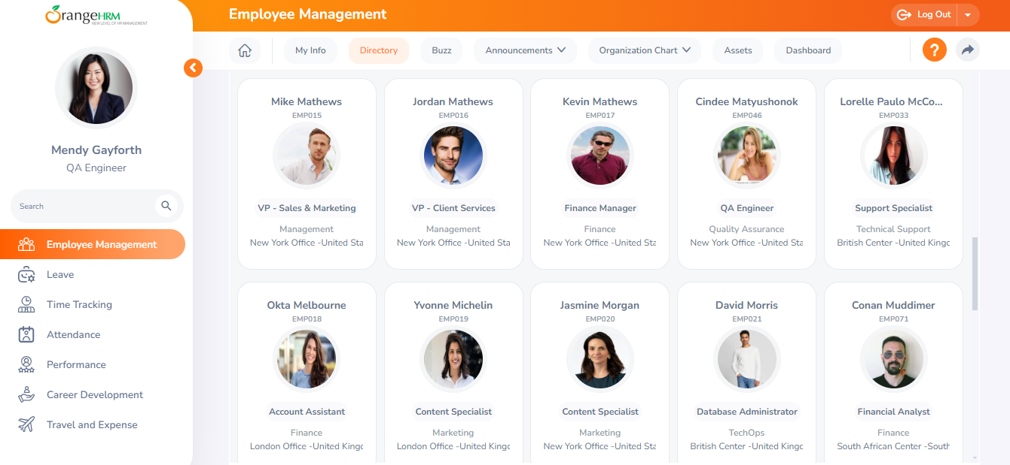

##### Image 13: Corporate Directory

### **Buzz**

You can set it up to show the buzz-related posts as widgets on the dashboard screen.

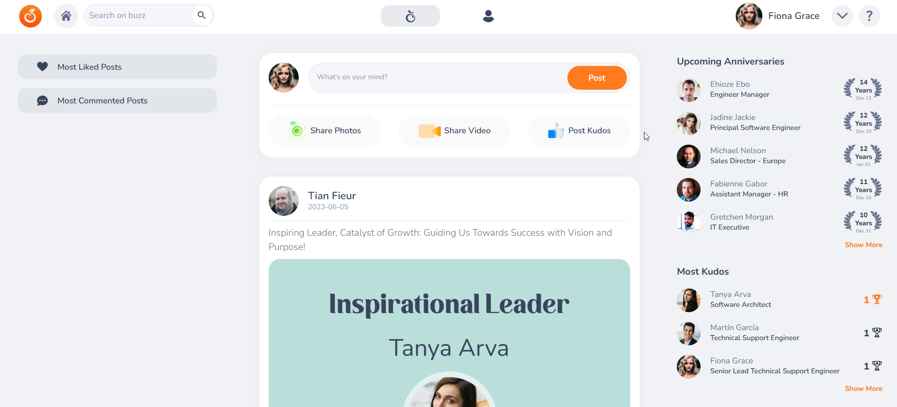

##### Image 14: Buzz widget

### **Announcements**

You can view the upcoming news under the news widgets and important documents such as leave legislation changes, policy changes, company guidelines, and employee handbook under the document widgets.

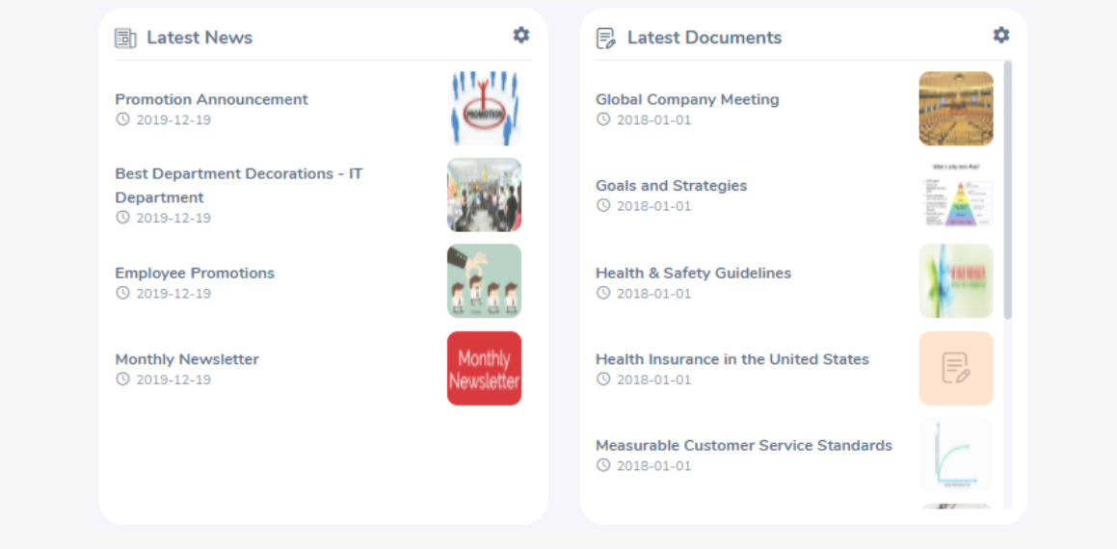

##### Image 15: News & Documents Widget

By selecting the news/document you can acknowledge that you have read and accepted the document.

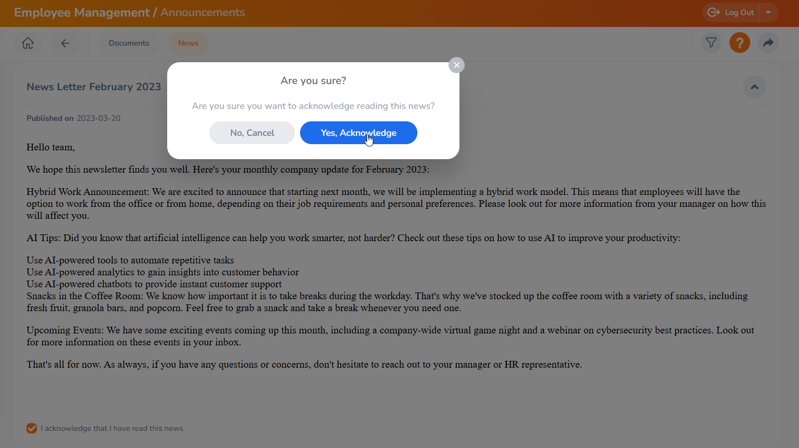

##### Image 16: News & Documents acknowledge

### **Organization Chart**

The organization chart provides a graphical representation of the employee hierarchy. Employees can view the full hierarchy from this screen and print it if they wish.

To navigate to the Org chart, go to **Employee Management -> Organization Chart -> View**

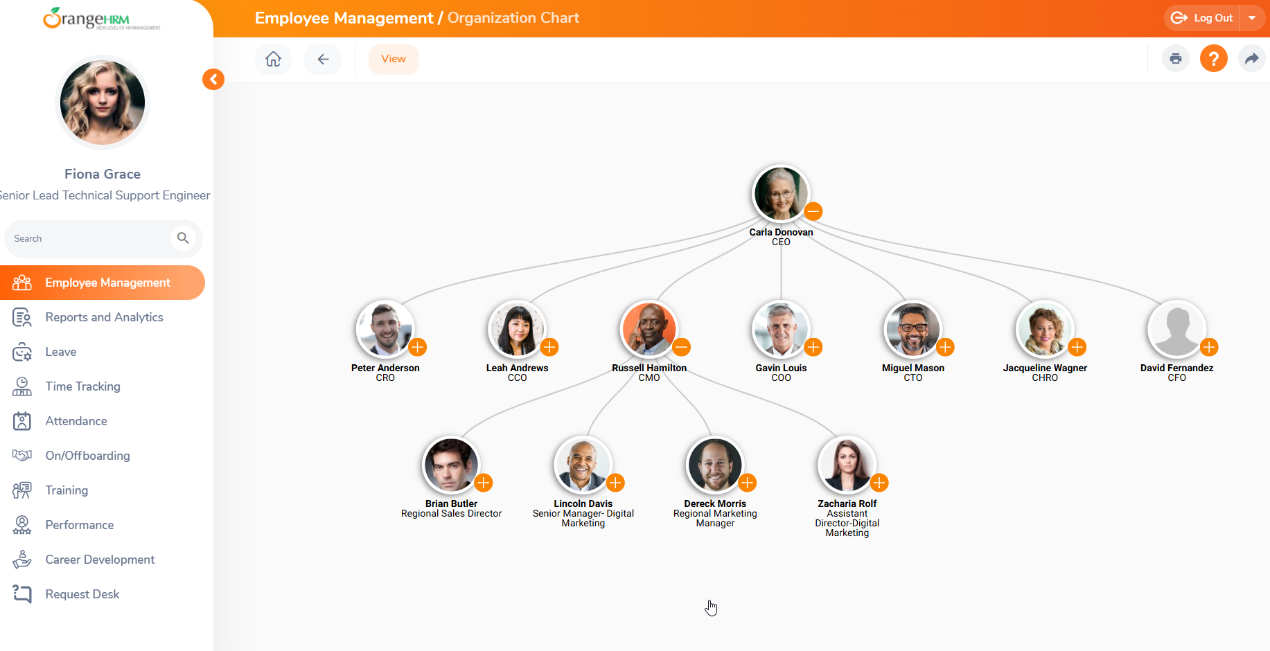

##### Image 17: Organization Chart View

### **Assets**

In this screen, you can view the assets that have been allocated for you. In order to view the Asset click the icon as shown below.

To access this feature go to **Employee Management -> Assets**

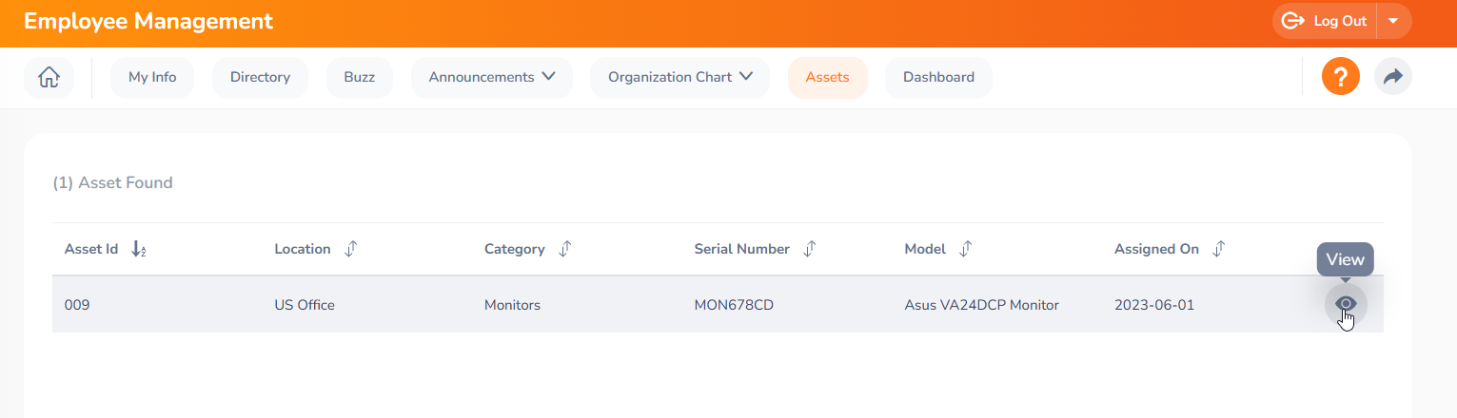

##### Image 18: View Assets

### **Dashboard and Menu options**

When you log in, the system will navigate you to the Dashboard screen or you can go to the dashboard screen by clicking the home icon from the top navigation bar.

The ‘My Actions’ widget shows the pending items that need to be performed by you. By clicking the item you can perform actions over the Appraisals, Goals, Onboarding activities, etc.

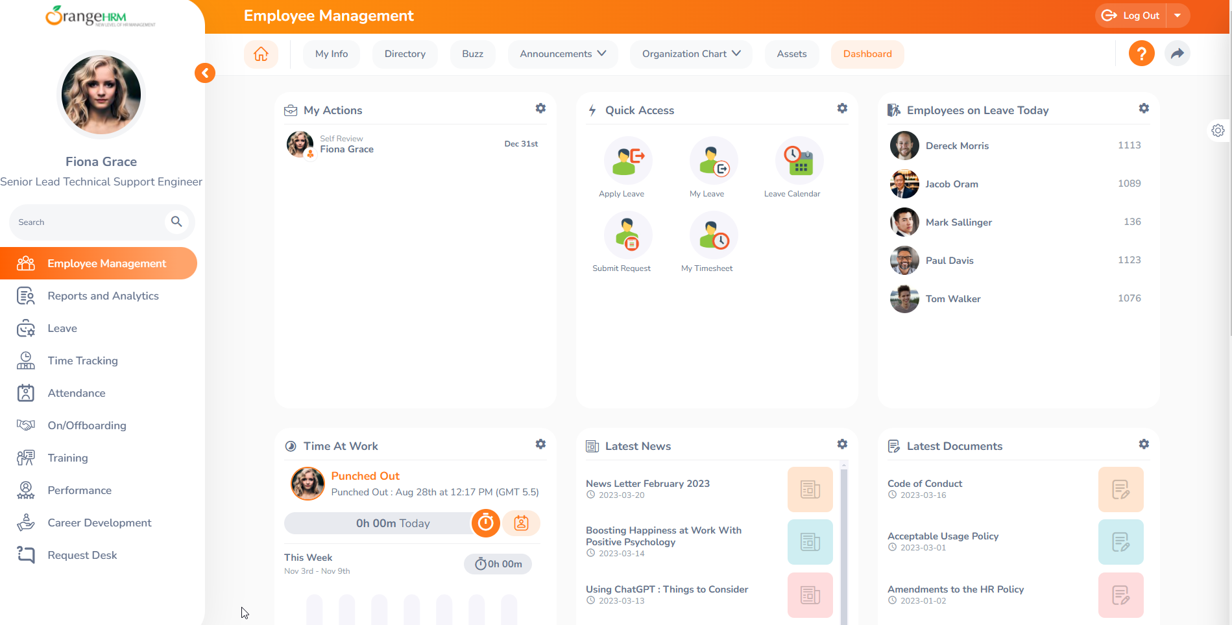

##### Image 19: OrangeHRM Dashboard

#### **My widget configuration**

By clicking on the configuration icon, users can see the widgets that are available to them. From there, they can either enable or disable the widgets they would like to see on their dashboard as per their preference.

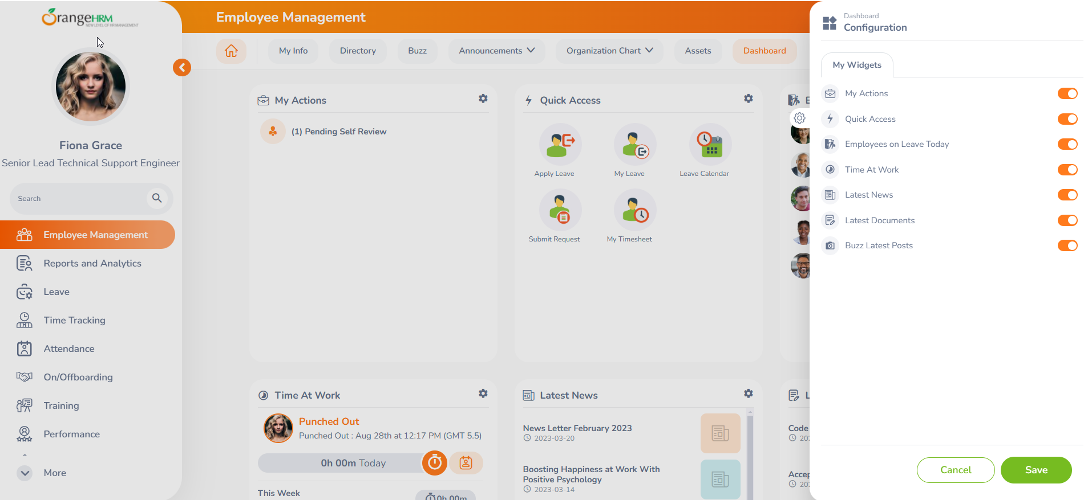

##### Image 20: My Widget Configuration

#### 

#### 

#### 

#### 

#### **My Actions**

The “My Actions” widget will display any pending tasks that need to be taken action on. For example: When appraisals have been created for an individual by HR, within the “My Actions” widget, that specific notification is displayed. If a subordinate has submitted their Appraisal or there are goals that the line manager needs to perform actions on, those notifications will also be shown within this widget.

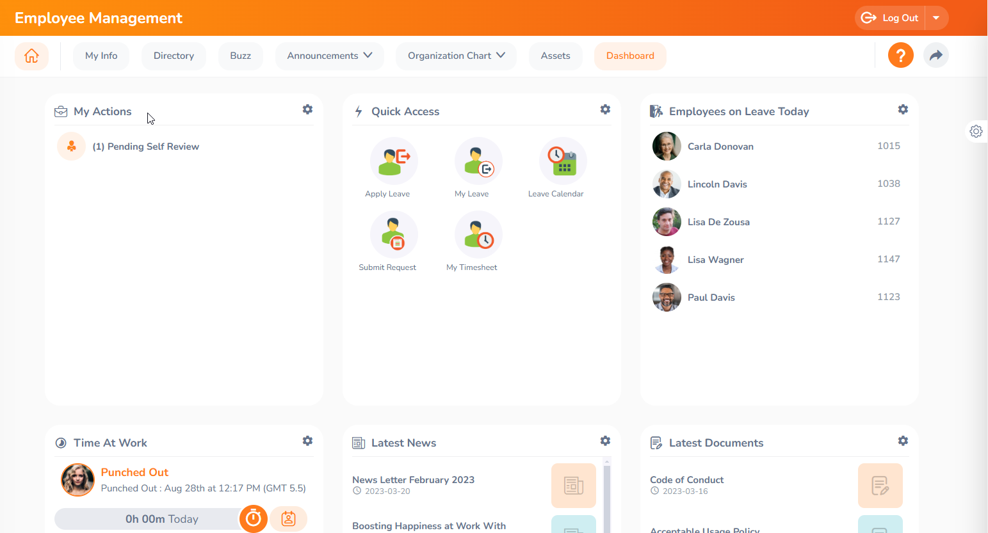

##### Image 21: My Action Widget

If there are any specific items that you wanted removed from the “My Actions” Widget click the configure icon in the top-right corner of the specific widget and disable/enable as per your preference.

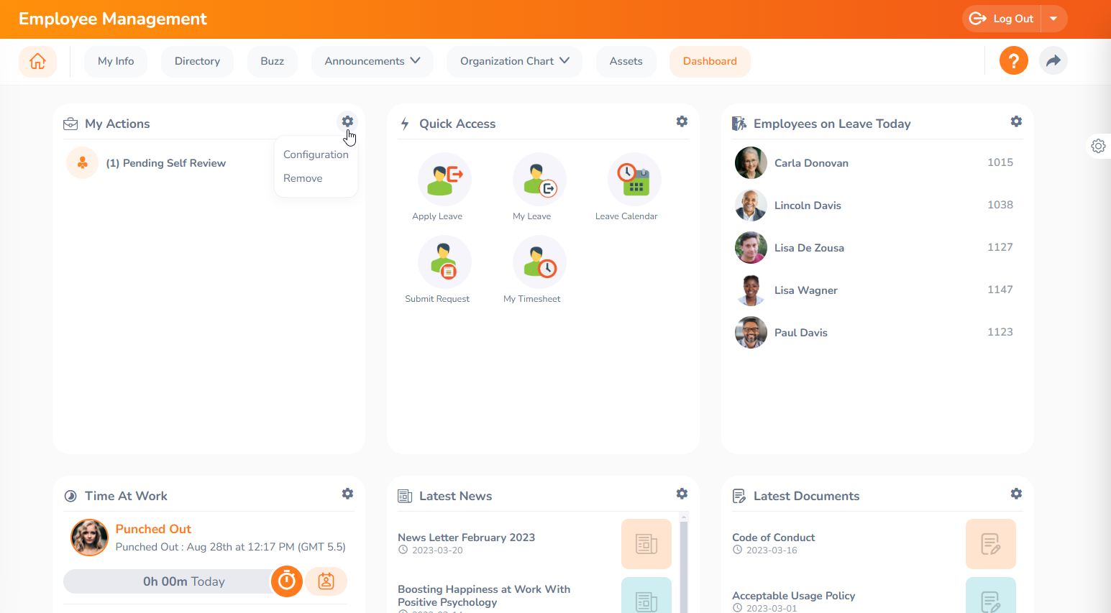

##### Image 22: My Action summary view & individual view

For example, if users click on the down arrow for Pending Appraisal Reviews within the widget, they can choose to show either a Summary of reviews or individual reviews related to the Performance module.

Should users wish to remove a widget completely, they can simply click on the configuration icon and select remove.

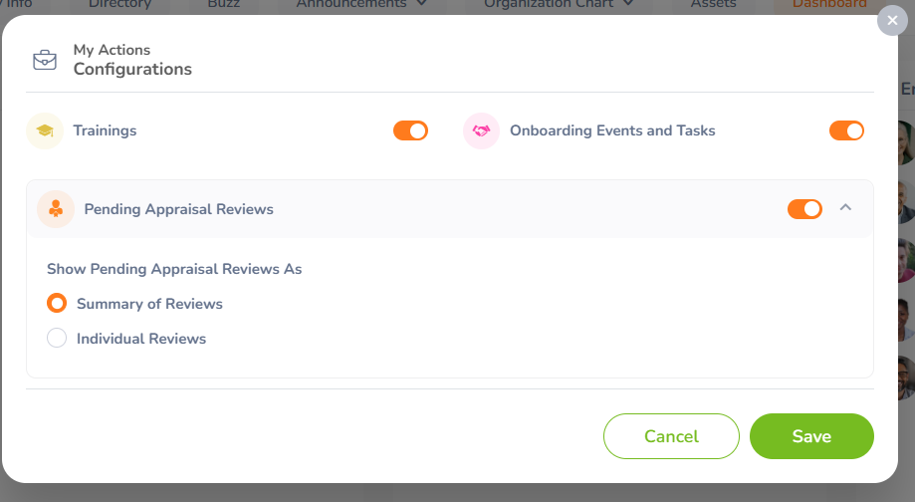

##### Image 23: My Action Configurations view

#### **My Shortcuts**

Through the ‘Quick access’ widget you can easily navigate to quickly access the module by using the shortcut keys.

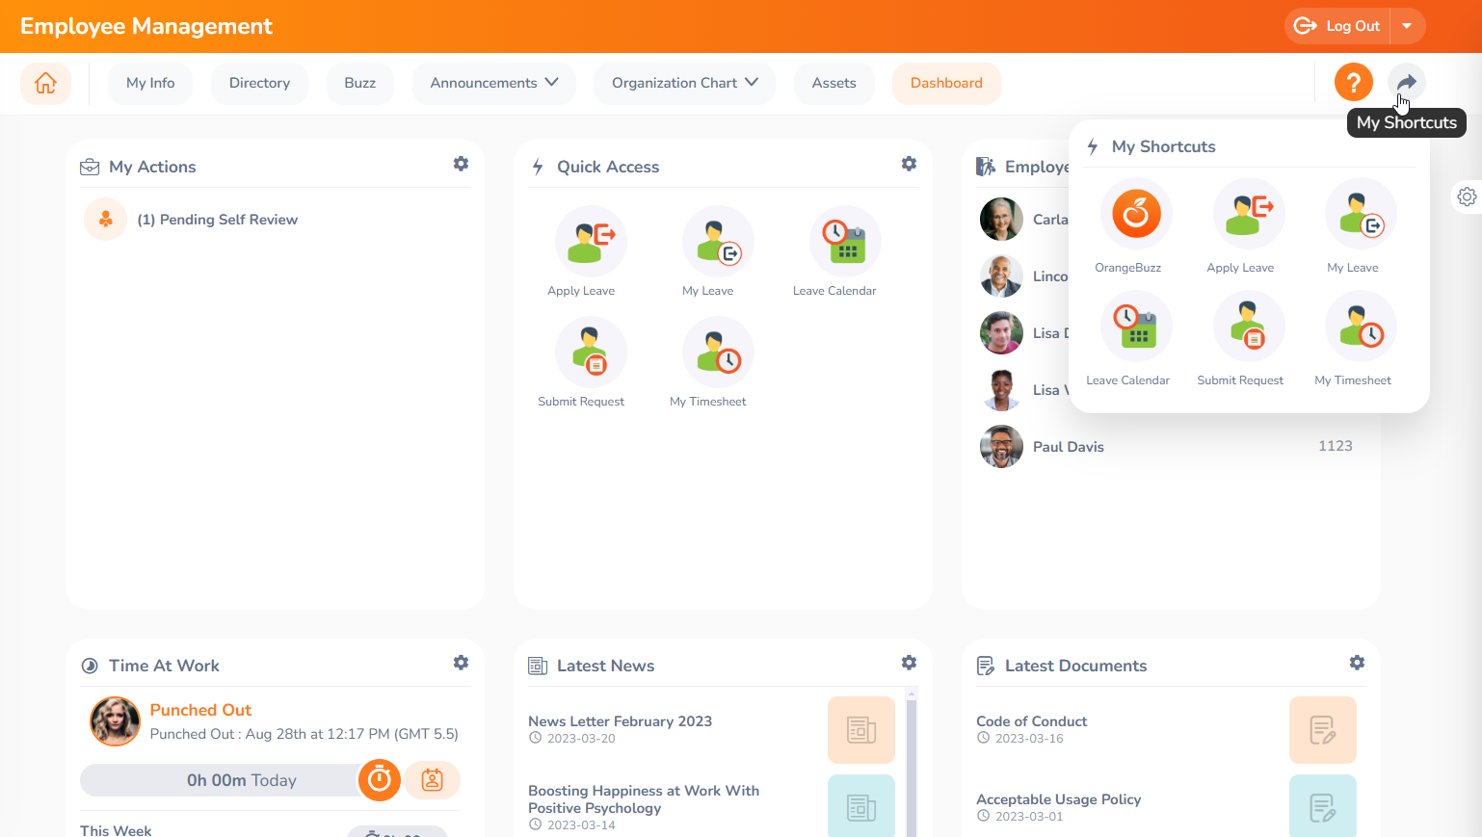

##### Image 24: My Shortcuts Widget

#### **Quick Access**

Through the 'Quick Access' widget, users can access admin-saved "quick access" screens. All saved shortcuts will be displayed there, and users can click the listed Quick Access to view the specific screens.

#### 

##### Image 25: Quick Access widget

## **My Settings**

In my settings, you can change your password as well as the preferred language and date format.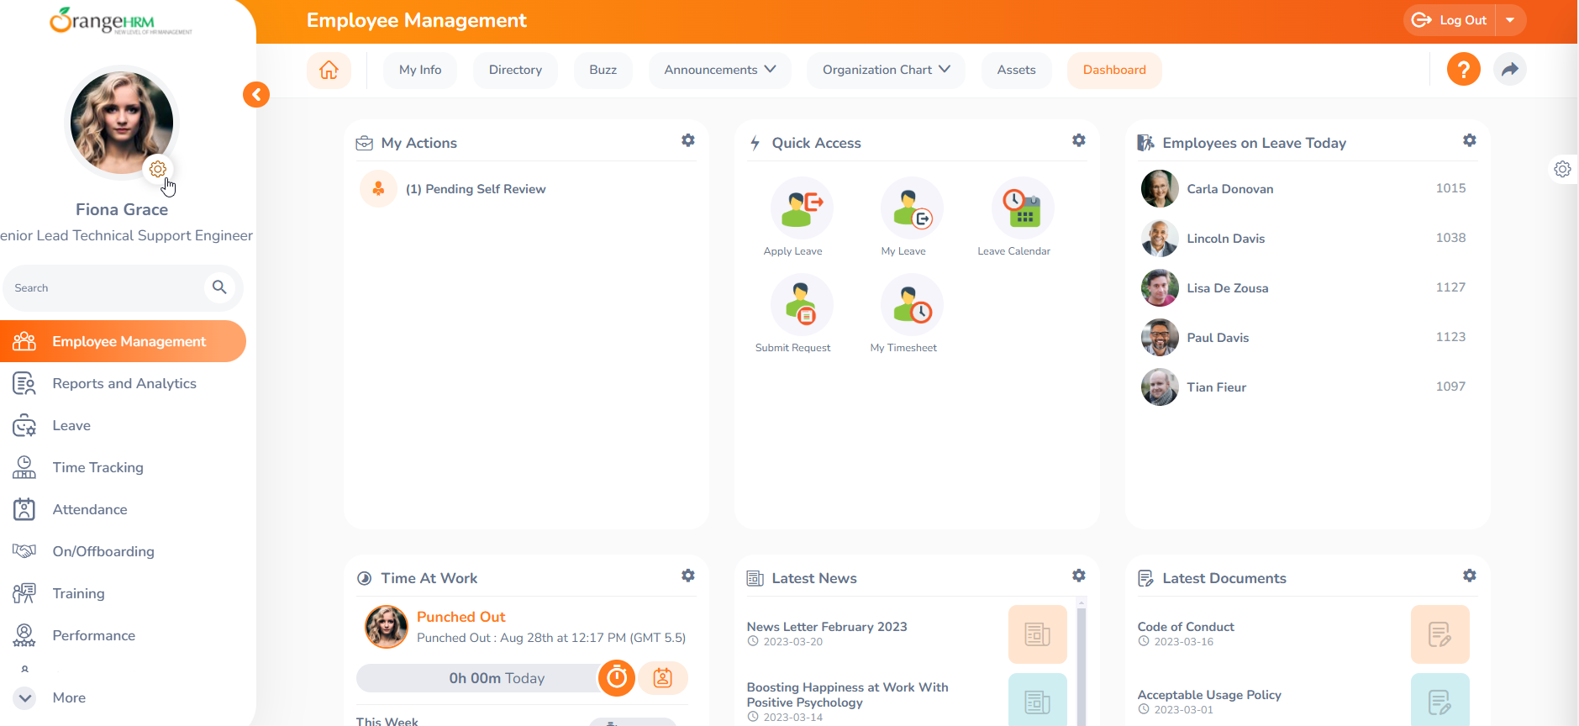

##### Image 26: Setting icon

# 

##### Image 27: Navigation My Settings

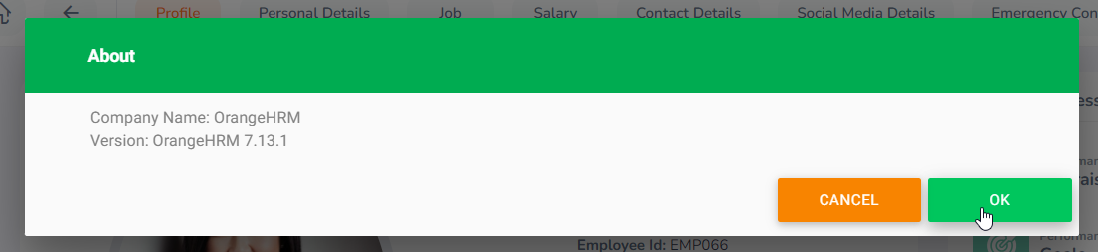

##### Image 28: About View

### **Change Password**

To change the password, simply navigate to **My Settings -> Change Password**. 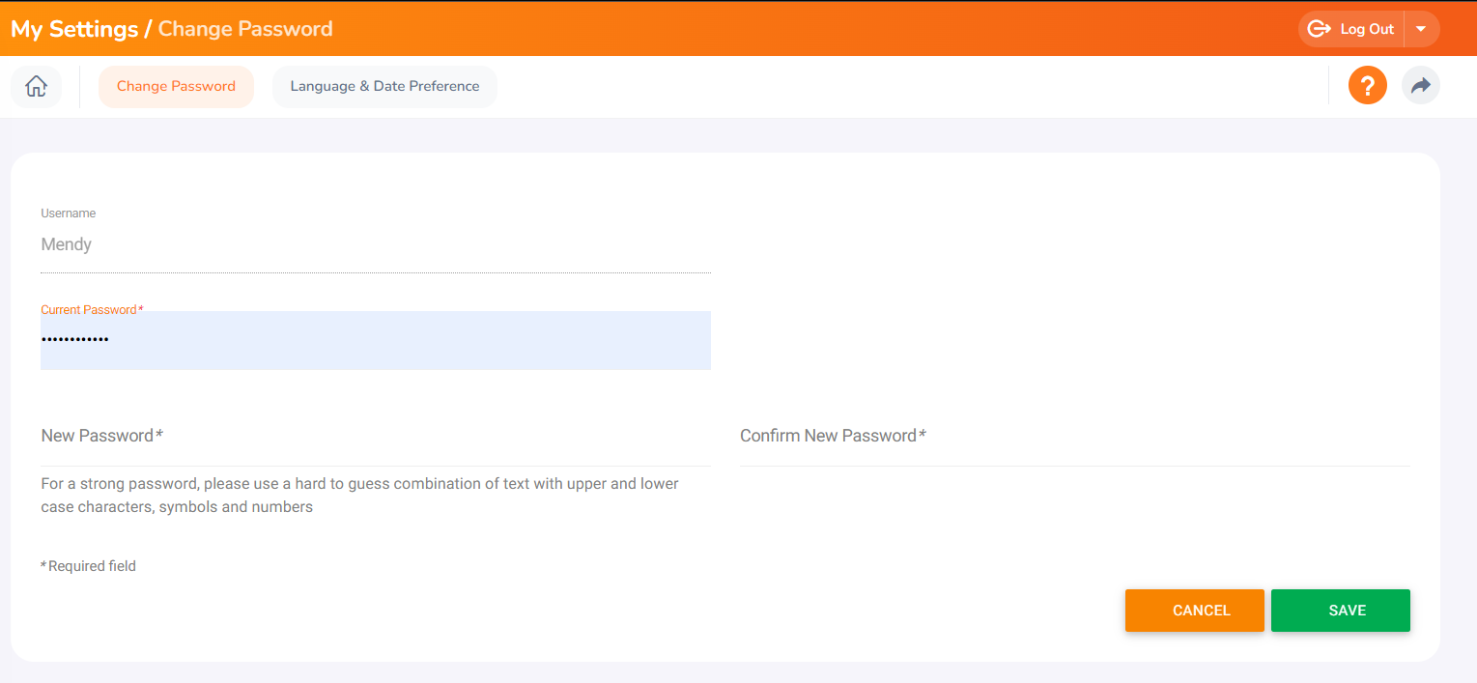

##### Image 29: Change Password

### **Language and Date Preference**

To access this feature, go to **My Settings -> Language and Date Preference**. This allows users to customize their language and date settings according to their preferences.

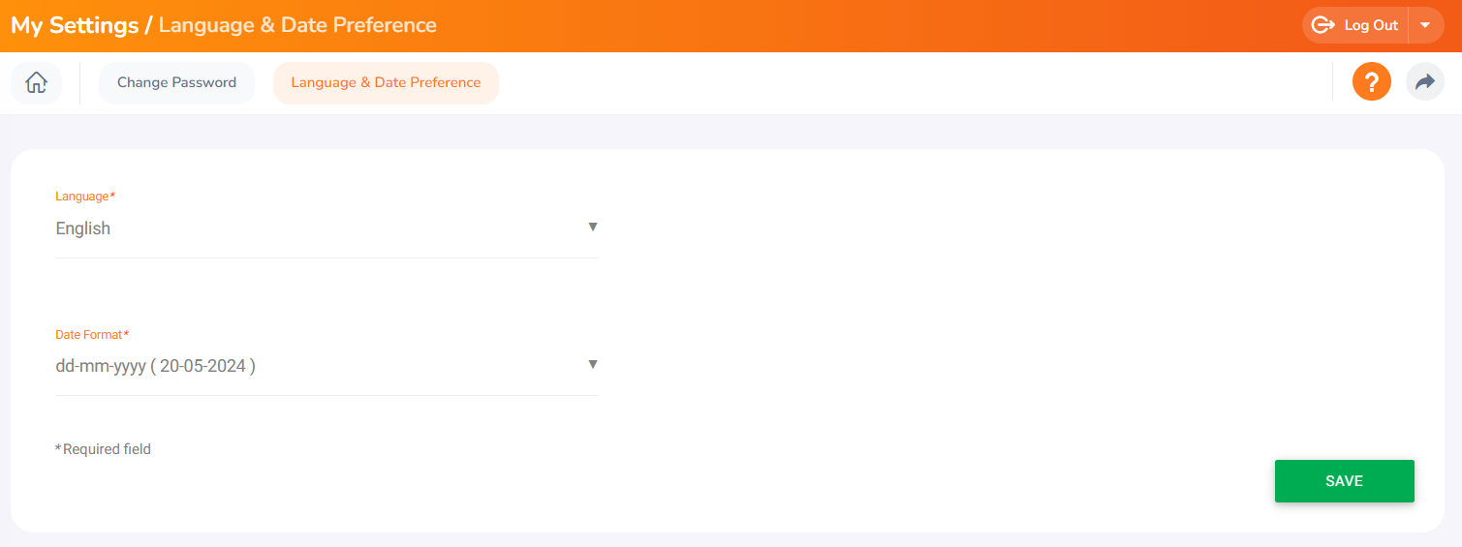

##### Image 30: Language and Date Preference

# 

# 

# **Resources**

This user guide has been designed for OrangeHRM and for any queries use the [OrangeHRM Help Portal](https://help.orangehrm.com/hc/en-us) or for any support matters drop an email to [goldsupport@orangehrm.com](mailto:goldsupport@orangehrm.com)

_END_