**Table of Contents**

Introduction 5

LOGIN 6

HR Administration 7

How to Add User Accounts 7

Users List Configuration 10

How to Manage Job Details 12

How to Add Job Titles 13

How to Manage Pay Grades 15

How to Delete Records 18

Announcements 19

News 19

Documents 20

How to access the Employee Profiles 28

How to create user accounts 37

How to Terminate an Employee 39

Dashboard and Menu Options 41

My Widget Configuration 42

My Actions 43

Quick Access 44

News and Documents 46

Organization Chart 48

Directory 49

Buzz 50

Reports and Analytics 51

RESOURCES 56

# 

**Table of Figures**

Image 1: Login Panel 6

Image 2: Add User 7

Image 3: Add User Window 8

Image 4: Edit User 9

Image 5: Filter User 9

Image 6: Configure Users 11

Image 7: Configure User Window 11

Image 8: Manage Job Tab 12

Image 9: Add Job Title Button 13

Image 10: Add Job Title Window 14

Image 11: Edit Job Title 14

Image 12: Add Pay Grade Button 15

Image 13: Add Pay Grade Window 15

Image 14: Edit Pay Grade Window 16

Image 15: Assign Currency 17

Image 16: Edit Currency 17

Image 17: Delete a Record 18

Image 18: Delete Button 18

Image 19: News Tab 19

Image 20: Documents Tab 20

Image 21: Profile 21

Image 22: Profile Picture 22

Image 23: Configure Profile Picture 23

Image 24: Job Tab 23

Image 25: Salary Tab 24

Image 26: More 25

Image 27: Add attachments 27

Image 28: Employee List 28

Image 29: Edit Personal Details 29

Image 30: Attachments 29

Image 31: Filter Employee List 30

Image 32: Edit Employee Job Details 32

Image 33: Add employee 33

Image 34: Add Employee Window 34

Image 35: Add Personal Details of an Employee 35

Image 36: Add Employment Details of an Employee 36

Image 37: Add User button 37

Image 38: Add User Window 38

Image 39: Terminate Employee 39

Image 40: Terminate Employment Windo 40

Image 41: Dashboard 41

Image 42: My Widget Configuration 42

Image 43: My Actions 43

Image 44: My Actions Configuration 43

Image 45: My Actions Configuration 44

Image 46: Add My Shortcut 44

Image 47: Quick Access Widget 45

Image 48: News and Documents widget 46

Image 49: How to Acknowledge 47

Image 50: Organization Chart 48

Image 51: Directory 49

Image 52: Buzz 50

Image 53: Reports and Analytics 51

Image 54: Add new report 52

Image 55: Report Name 52

Image 56: Selection Criteria 53

Image 57: Add Display Fields 54

Image 58: Generate Report 55

# 

**Tables**

Table 1: Fields Under Add User 8

Table 2: Filter Users 10

Table 4: Tabs under the More section 26

Table 5: Filter field 31

# 

# 

# 

# **Introduction**

The purpose of this document is to serve as a guide for Regional Admins to help them understand how to use the licensed modules and gain a deeper insight into the system functionalities and capabilities. Step-by-step instructions and images are also included to assist users in accessing and navigating the system.

This user guide is intended for Regional Admins in the organization. It covers the following modules:

* Log in
* HR Administration
  + Users
* How to add users
* Job
  + Manage Job Titles
  + Manage Pay Grades
* Announcements
  + News & Documents
* Employee Management
  + Profile
* How to access employee profiles
  + How to access the Employee List
  + How to terminate an employee
* Dashboard and Menu options
  + My Widget Configurations
  + My Actions
  + Quick Access
  + News and Documents
  + Preferences
  + Organization Chart
  + Directory
  + Buzz
* Reports and Analytics
  + How to create reports using OrangeHRM

# **LOGIN**

Regional Admin can use the standard login screen to log into the OrangeHRM system.

Step 1 –Enter your OrangeHRM URL address in the browser. The OrangeHRM Login page should look like the one below, In the login panel, enter your username and password and click ‘Login’.

OrangeHRM URL - < Enter your instance URL here >

#### 

#### Image 1: Login Panel

# **HR Administration**

## **How to Add User Accounts**

As a Regional Admin, adding or updating users involves managing employee profiles and their associated roles within the organization.

Add Users

You can see all the employees with the Username and User roles. You can add new Users to the system by clicking the “Add User button” in the top right corner of the screen.

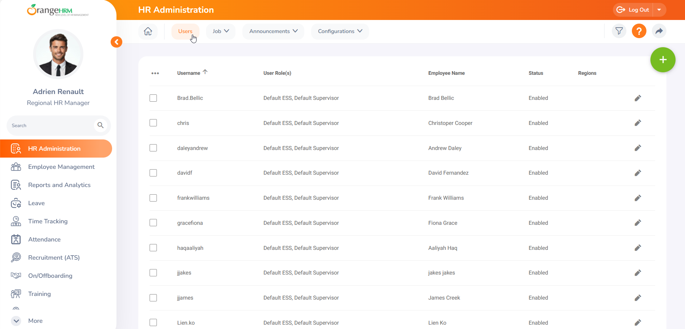

#### Image 2: Add User

Once you click the “Add User button” the Add User window will appear like this. Fill in the required fields and enable the user to log in to the system.

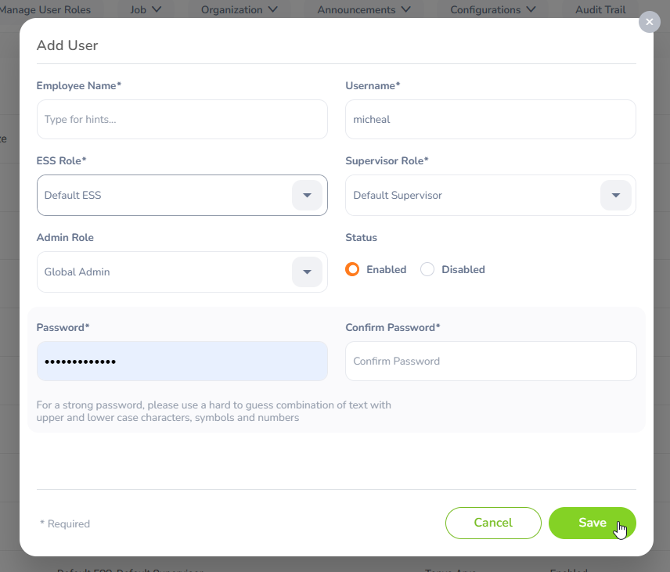

#### Image 3: Add User Window

| **Field Name** | **Description** |
| --- | --- |
| Employee Name | In this section, you can search by the employee's name |
| Username | Enter the employee's username in this section |
| ESS Role | Select the ESS Role from the Dropdown menu |
| Supervisor Role | Select the Supervisor Role from the Dropdown menu |
| Admin Role | Select the Admin Role from the Dropdown menu |
| Status | Select the status Enabled or Disabled |
| Password | Create a Strong Password. |
| Confirm Password | Retype the same password to confirm |

##### Table 1: Fields Under Add User

Edit Users

To edit user accounts, click on the “edit button”, and the following window will display, Make the changes, and then click the “Save button” to apply the updates.

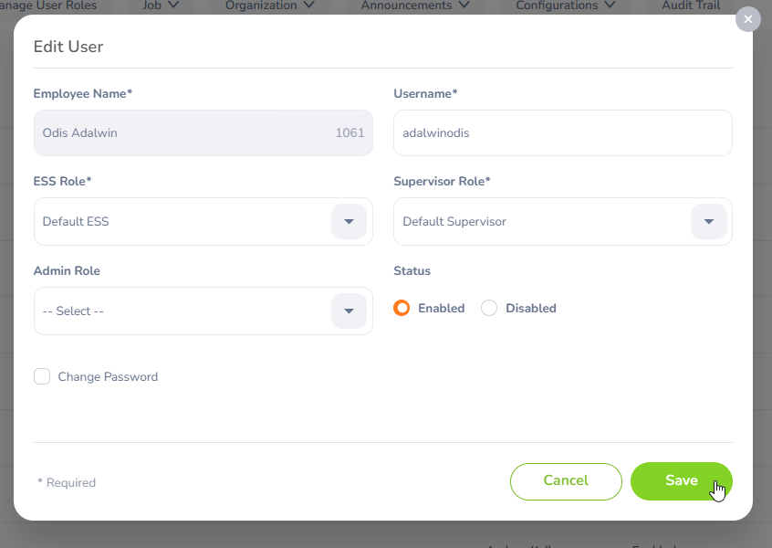

#### Image 4: Edit User

Filter Users

Click the “Filter” icon in the top-right corner of the User List. This will open a popup window as shown below. Click the “Search button” after filling in the fields.

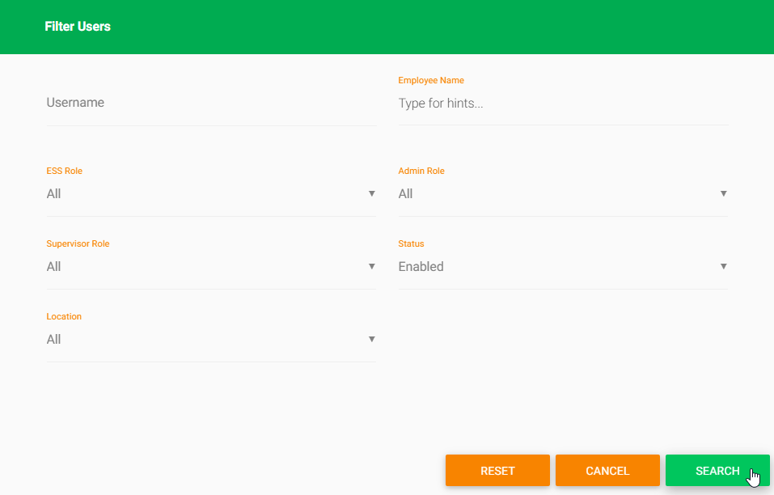

#### Image 5: Filter User

| **Filter** | **Description** |
| --- | --- |
| Username | Filter by Employee Username |
| Employee Name | Filter by Employee name |
| ESS Role | Filter by ESS Role |
| Admin Role | Filter by Admin Role |
| Supervisor Role | Filter by the Supervisor Role |
| Status | Filter by Employment Status. You have these options:   * All * Enabled * Disabled |
| Location | Filter by their location |

##### Table 2: Filter Users

### 

## **Users List Configuration**

In the top-left corner of your screen, you will see the “Configure” option. Select the “Configure button” to proceed.

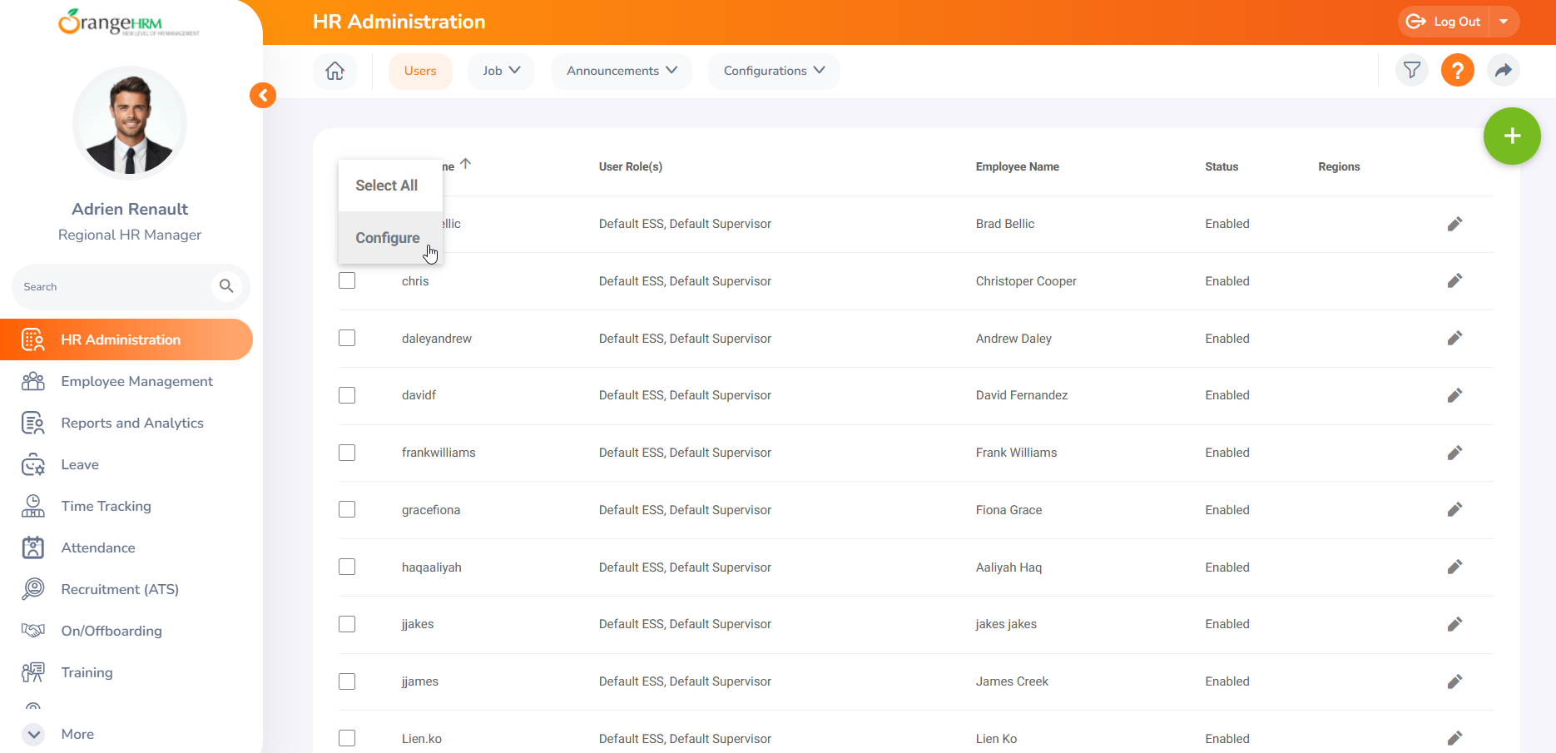

#### Image 6: Configure Users

After clicking the “Configure button”, a window will pop up. Select the fields you want to display in the list view, and then click “Save” to apply your changes.

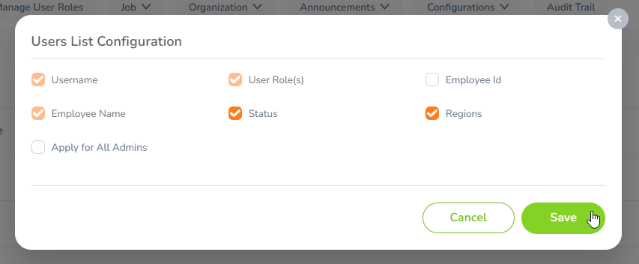

#### Image 7: Configure User Window

## **How to Manage Job Details**

As a Regional Admin, managing job-related information involves overseeing and updating details related to employees' roles, responsibilities, and job status within the region.

By clicking on the “Job tab”, you can access and manage the following:

* Job Titles
* Pay Grades

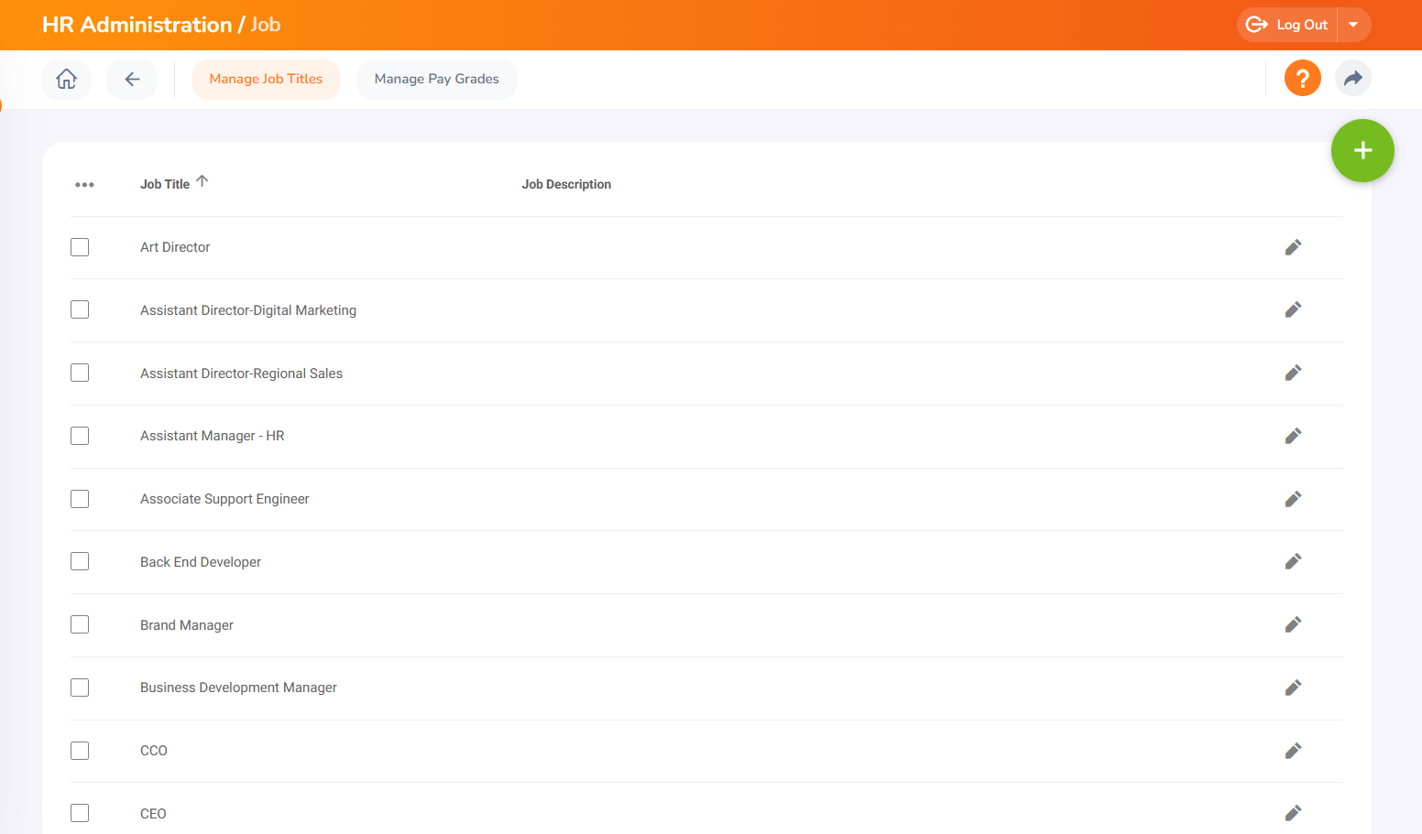

#### Image 8: Manage Job Tab

### 

### **How to Add Job Titles**

In the “Manage Job Titles tab”, you can add and update the job titles for employees within the organization. To add a job title, click on the “Add Job Title button” located in the top-right corner of the screen.

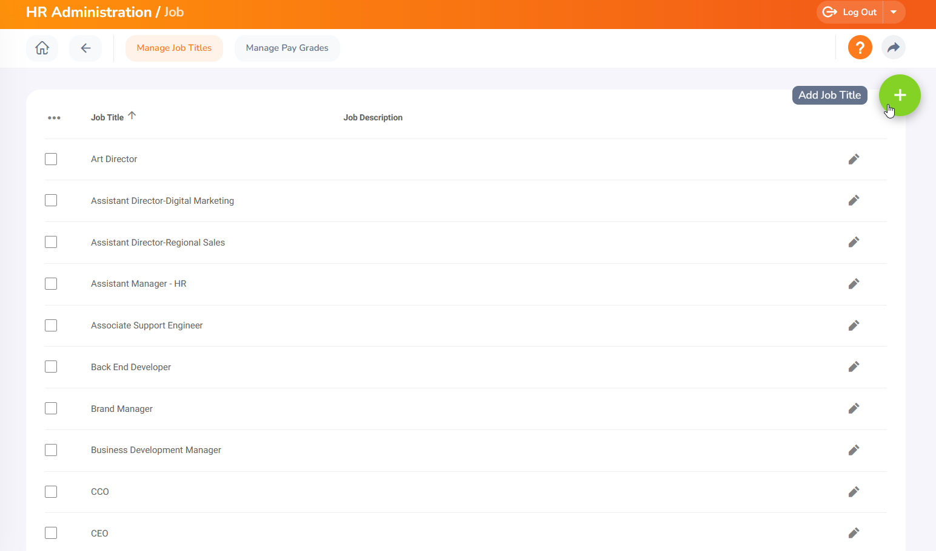

#### Image 9: Add Job Title Button

Once you click the “Add Job Title button”, the following window will display. Fill in the required fields and click the Save button.

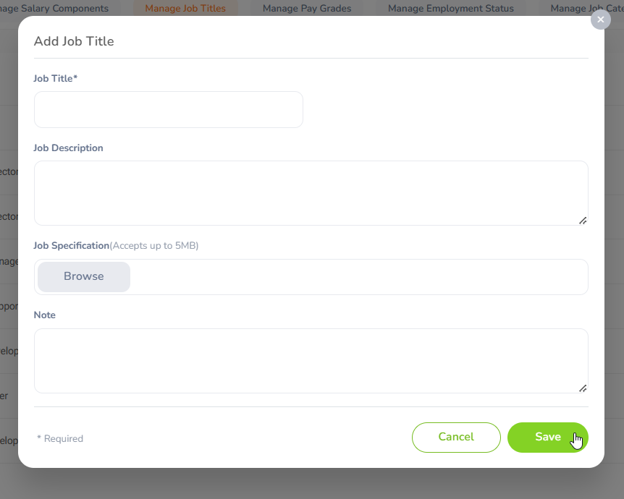

#### Image 10: Add Job Title Window

Edit Job Titles

Select the record you want to edit and click on the “Edit Button”, The following window will display, allowing you to make changes. Make the alterations and click Save to apply the changes.

# 

#### Image 11: Edit Job Title

### **How to Manage Pay Grades**

To manage pay grades, you can follow these steps to assign, edit, or remove pay grades for employees. Click on the Manage Pay Grade tab. To add a pay grade, click on the Add Pay Grade button.

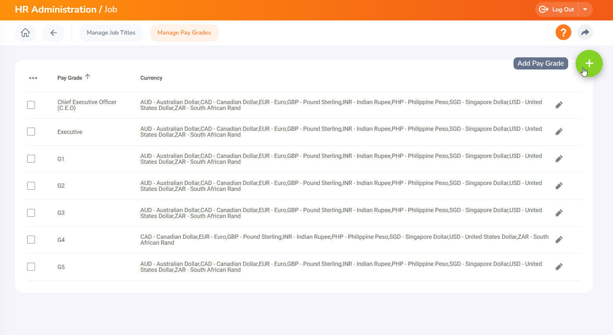

#### Image 12: Add Pay Grade Button

Add Pay Grade

Once you click on the Add Pay Grade button, the following window will display. Fill in the required field pay grade name, and then click the Save button.

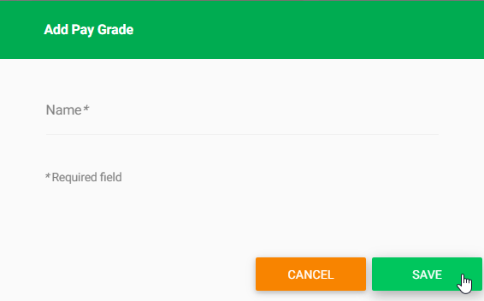

#### Image 13: Add Pay Grade Window

How to Edit Pay Grades and Assign Currency

To edit a pay grade, select the record, and click on the edit button to proceed. Once you click the Edit button, you will gain access to edit the previous pay grade records.

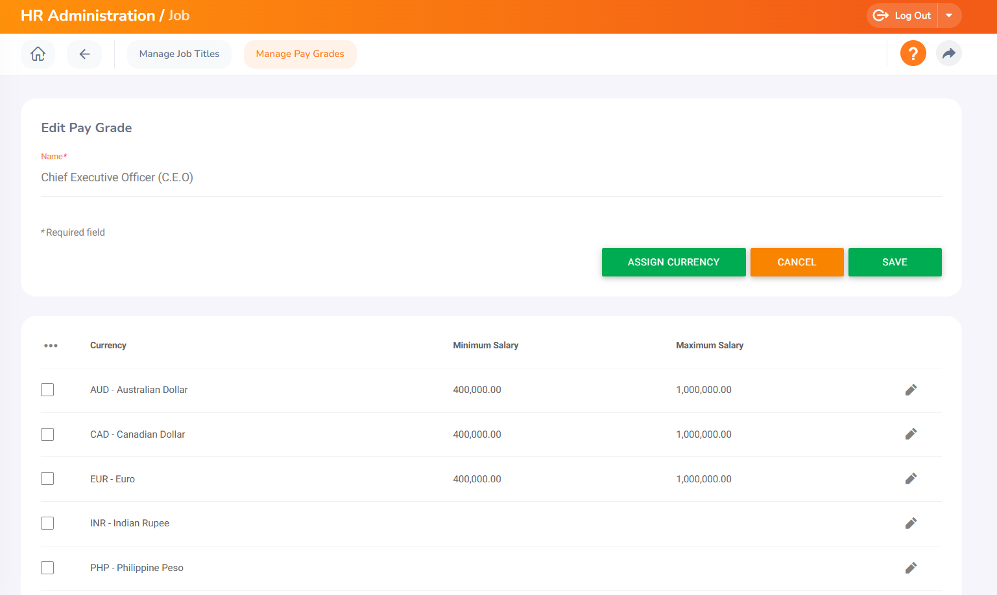

#### Image 14: Edit Pay Grade Window

You also have the option to assign a currency. Click on the Assign Currency button to proceed. Once you click it, the following window will display. Fill in the required details and click Save to complete the process.

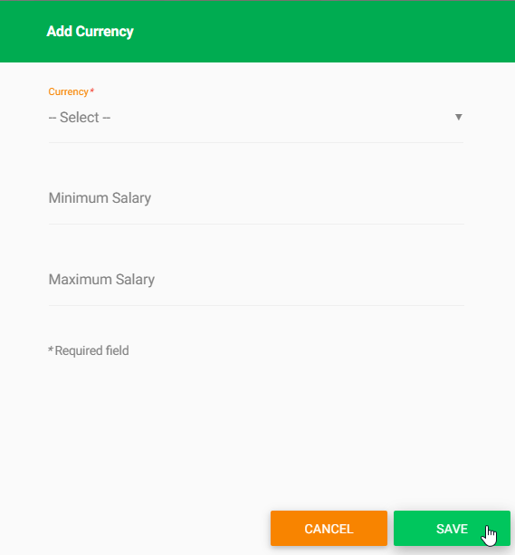

#### Image 15: Assign Currency

You can edit the assigned currency by clicking the Edit Currency button. You can make the changes and click Save to apply the changes.

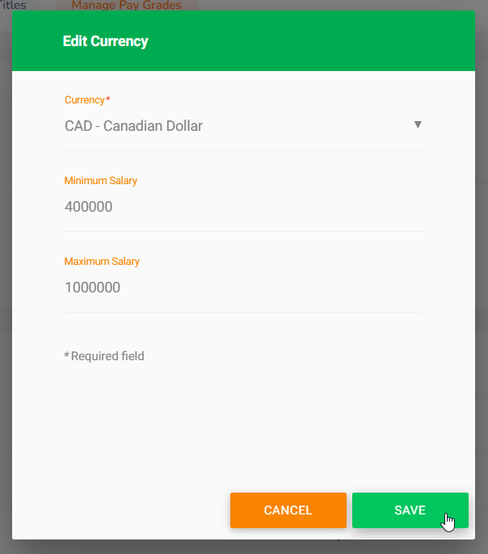

#### Image 16: Edit Currency

## **How to Delete Records**

To delete any record(s), select the records you want to delete and click the three dots located in the top-left corner of the screen.

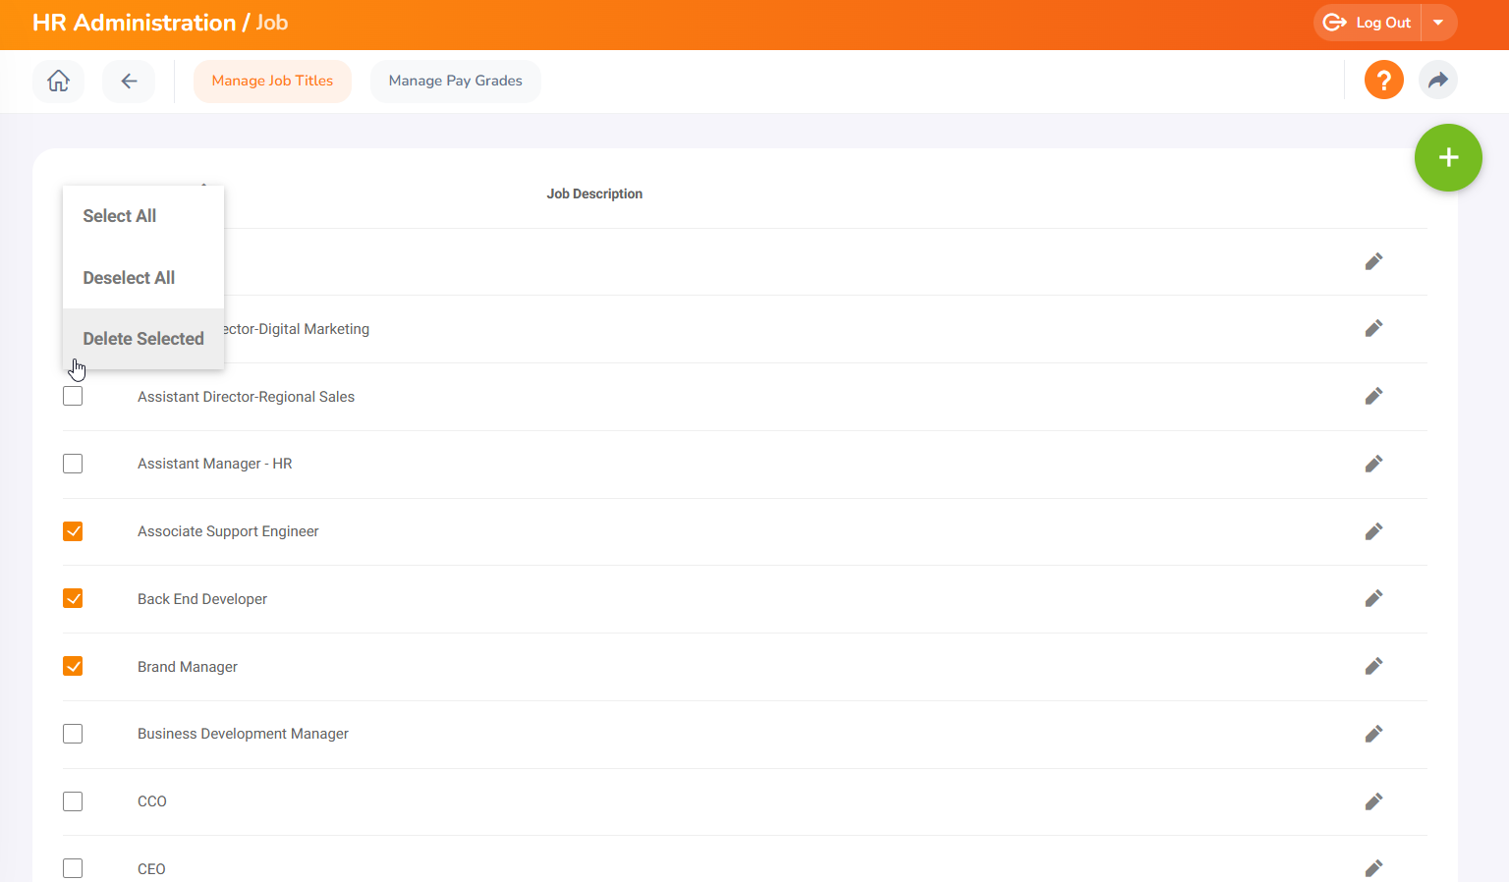

#### Image 17: Delete a Record

Click the Yes, Delete button to confirm the deletion.

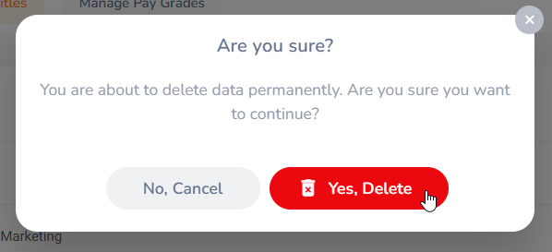

#### Image 18: Delete Button

## **Announcements**

The Announcement section allows you to manage and share news, and documents, and organize them into categories for better accessibility and communication within the organization. Under the Announcement section, you have the following options:

### News

You can publish news across the company, targeting various locations and user roles, and request employee acknowledgment of the news. Additionally, you have the option to Configure news Lists, Attach documents, and Filter the records.

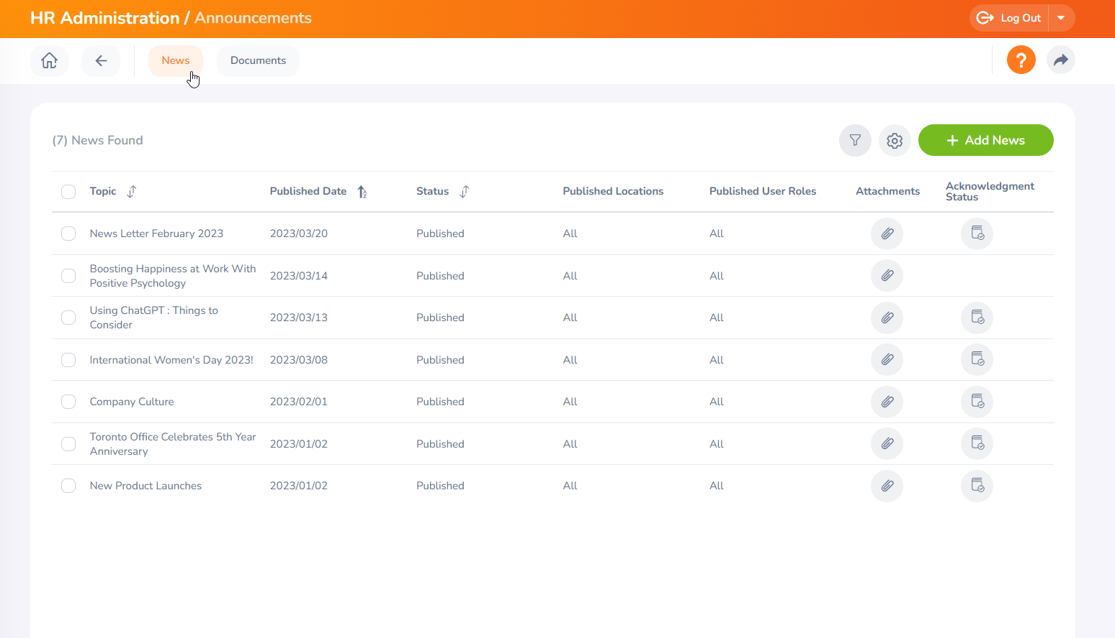

#### Image 19: News Tab

## 

### 

### Documents

In this section, you can add documents such as company policies, amendments to the policies, and other important files. You can also target specific locations and user roles, request employee acknowledgment, attach related documents, and filter the records.

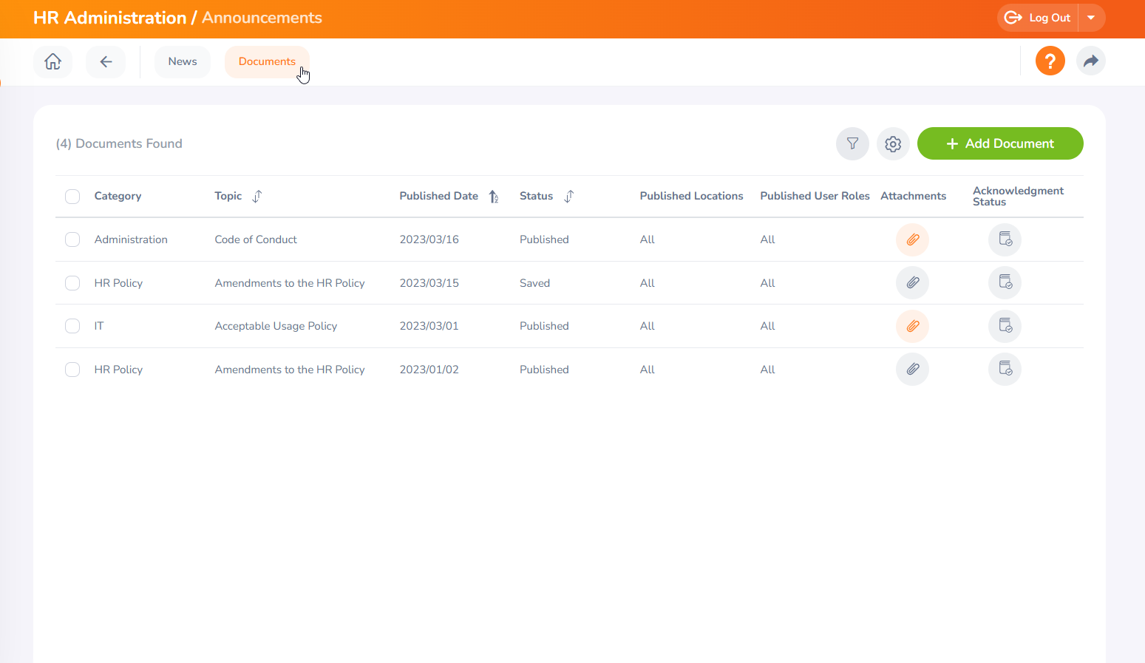

#### Image 20: Documents Tab

## 

## 

## 

## 

## 

## 

## 

## 

## 

## 

## 

## 

## 

**Employee Management**Once you have selected the employee from the list, you can update their details as explained below.

**Personal Details**

All employees have access to view this information; however, Regional Administrators possess the authorization to modify specifics like Employee Names, Gender, and other personal details recorded within the system for the respective region. Once the changes are done click on ‘Save’ to save the changes.

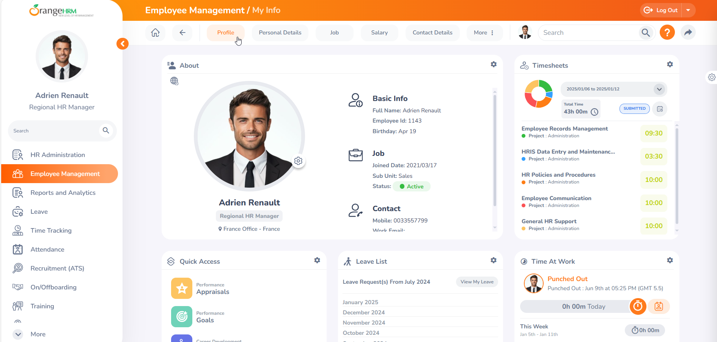

#### Image 21: Profile

The Employee Profile is organized into eight distinct tabs, each serving a specific purpose to comprehensively manage employee information. Personal Details, Job, Salary, Contact details, Social media details, Emergency contacts, Dependents and More.

**Profile**

In this section, you can view all the general information about the employee. To change the employee profile picture, go to Profile, and in the "About" section, you can change your profile picture. Please refer to the following screenshot.

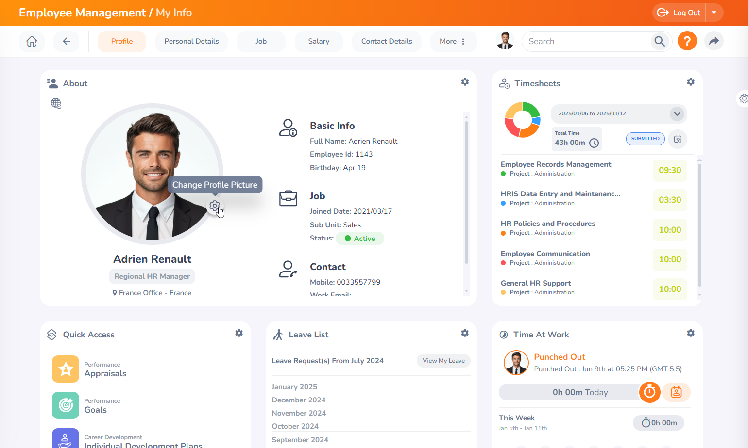

#### Image 22: Profile Picture

A Modal window would appear as below. You can click on the photograph and browse to select the image you wish to use.

Select your new picture and scale your image so the profile picture contains the part of the image that you want. After scaling and cropping the image, save it as your profile picture.

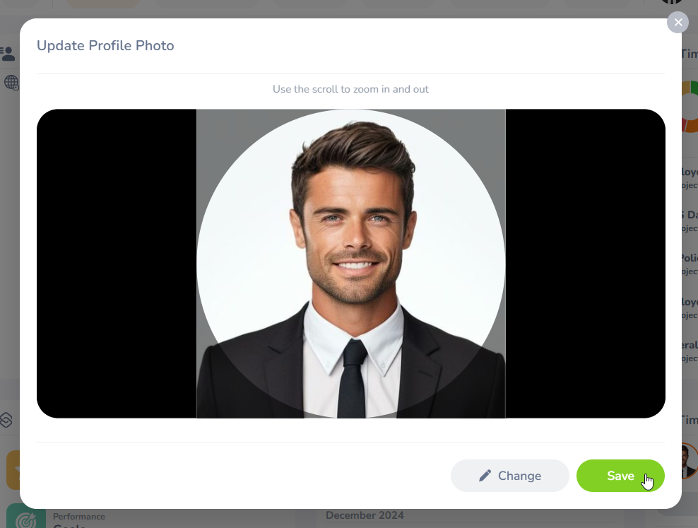

#### Image 23: Configure Profile Picture

**Job**

This tab contains all the information about your Job. If you go to the employee job tab as the admin you can update their job details.

#### 

#### Image 24: Job Tab

**Salary**

The Salary tab displays an employee's salary details and history of updates or transactions. Only HR and admins can access this information within the profile.

#### 

#### Image 25: Salary Tab

**More**

The More tab provides access to additional PIM tabs related to an employee's profile. It allows the insertion of extra employee information and includes both default and custom PIM tabs. The following default PIMtabs are available under the More tab.

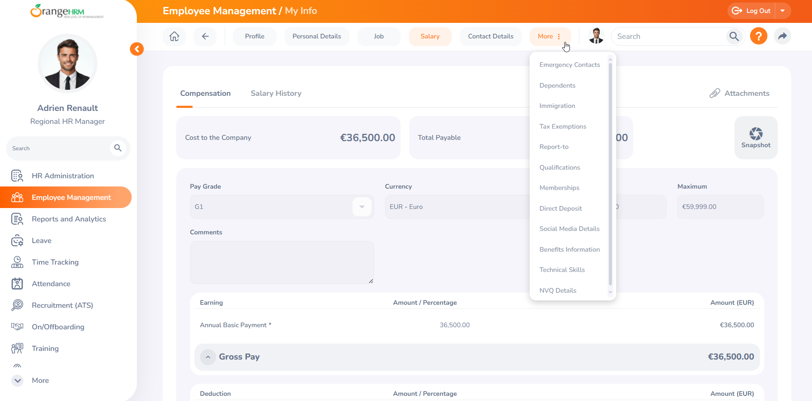

#### Image 26: More

| **More Section** | **Description** | **Access for Regional Admin** | **Access for Self** |
| --- | --- | --- | --- |
| Contact Details | Maintains an employee's contact information including work email. | View/Edit | View/Edit |
| Emergency Contacts | This section allows you to input and manage contact information for individuals to be reached in case of an emergency. | View/Edit | View/Edit |
| Dependents | Maintains an employee's dependents information. | View/Edit | View/Edit |
| Immigration | Employee's immigration records are added here in this tab. Any immigration documents can be added and uploaded in this tab. | View/Edit | View/Edit |
| Report to | Employees can view their assigned Regional Admins and subordinates on this screen. Regional Admins can view and edit their subordinates' reports. | View/Edit | View |
| Qualifications | Employee's qualifications include work experience, education, skills, languages, and licenses. Regional Admins and Employees can add or update the information on this screen. | View/Edit | View/Edit |
| Memberships | If an employee attains a membership that can be added and viewed. | View/Edit | View/Edit |
| Direct Deposit | Employees' bank details are added here. | View | View |
| Social Media details | In this tab, employees can add their social media details including links to the social media. | View/Edit | View/Edit |
| Training details | If an employee completes any training, those details are added here by HR. You can view the course name and the progress of the course as well. | View/Edit | View |

##### 

##### Table 4: Tabs under the More section

Uploading Attachments under My Info Tab

In each Employee Profile, Regional Admins and Employees have the option to add an attachment.

For example, My info > Personal Details > Attachment option. You can add an attachment of up to 5MB in size.

#### 

#### Image 27: Add attachments

## 

## **How to access the Employee Profiles**

Employee List

As a Regional Admin, you can go to Employee Management > Employee List to view the subordinate's job information and the other information as described in Table 1.

As part of the HR process, Regional Admins have permission to edit and manage employee details. This user guide provides instructions for Regional Administrators on how to edit and manage employee details using the OrangeHRM system.

From the dashboard, Navigate to Employee Management and select the employee profile you wish to access.

#### 

#### Image 28: Employee List

### 

In this section, you can view/edit all the Employee Details related to the Employee that you have selected. Apart from the Personal details Regional Admins can also edit details such as Additional Information Health Insurance Company, Gender Type, and ISpring ID.

#### 

#### Image 29: Edit Personal Details

#### 

Regional Admins have access to view or add any attachments under Employee personal details. Regional Admins can add attachments by clicking the add button.

#### 

#### Image 30: Attachments

#### 

Filter Employee List

The Regional Admin can select the following filters to further narrow down the subordinate list.

#### 

#### Image 31: Filter Employee List

| **Filter** | **Description** |
| --- | --- |
| Employee Name | Filter by employee name |
| Employee ID | Filter by Employee ID |
| Employment Status | Filter by Employment Status |
| Supervisor name | Gives a list of employees who are subordinates of the selected supervisor. |
| Job Title | Filter by the Job Title |
| Sub Unit | Filter by the Department |
| Include | Search current or past employees Or both. |
| Location | Filter by the location where they work |
| Cost Center | Filter by the Cost Center |
| Make Filter Default | Save the above filter selection as the default search every time the user accesses the employee list. |

##### 

##### Table 5: Filter field

Job

The Job section contains all the employee's job-related information. Employees have access to view this information; however, Regional Administrators possess the authorization to modify details in the Job tab.

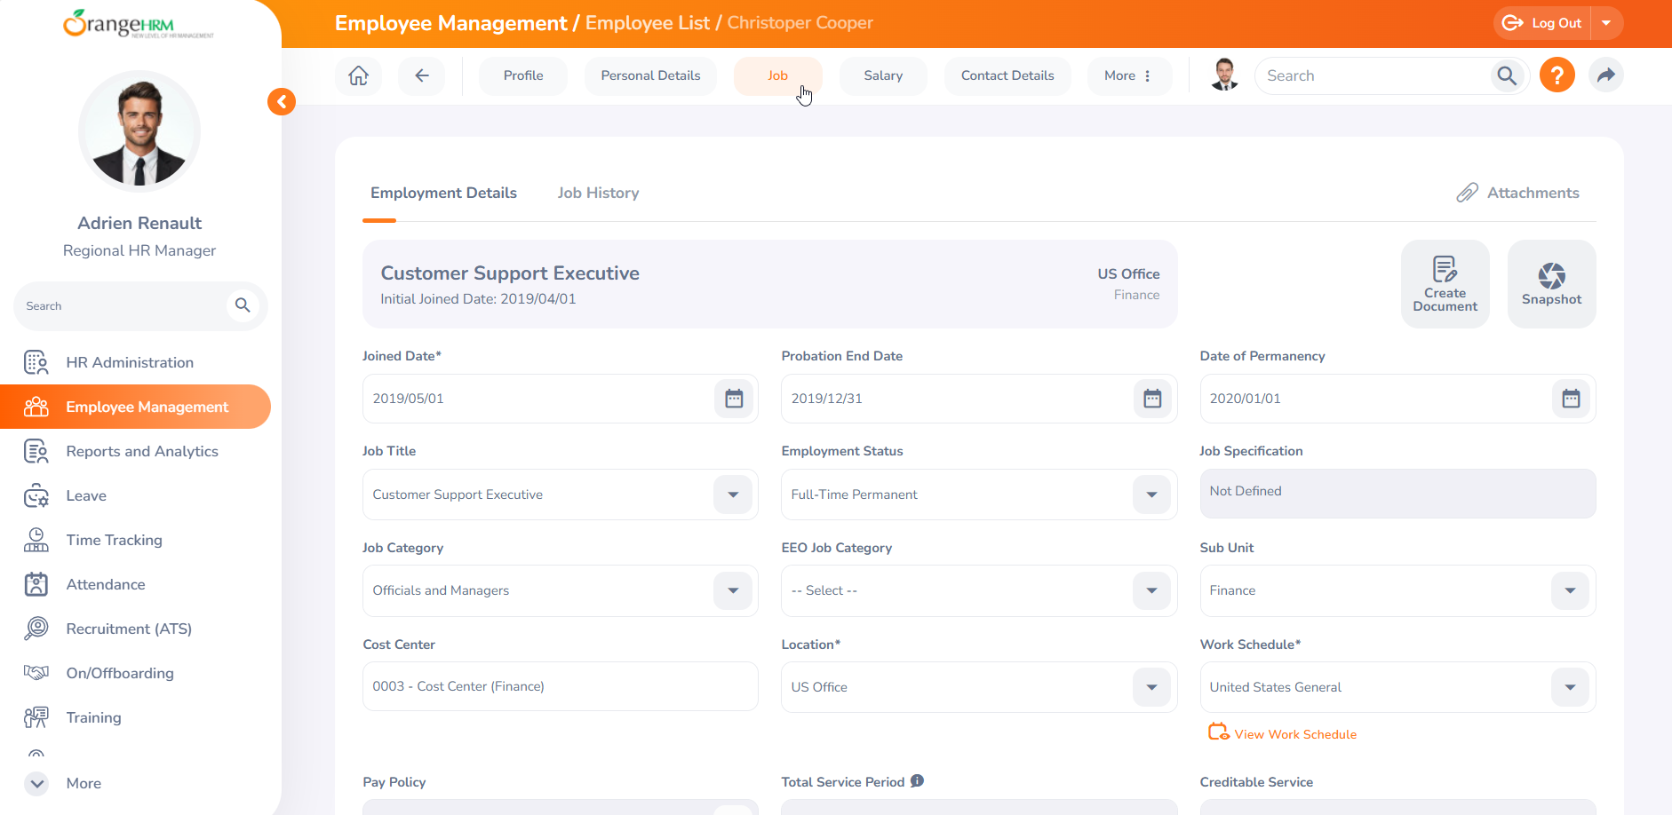

#### Image 32: Edit Employee Job Details

Apart from the Employee details Regional Admins can also edit details such as,

* Additional Job Information
* Maternity
* Working Scenario
* Compensation Details
* Position Details
* Taxation Type
* Transfer / Replacement Info
* Employee Replacement Details
* Termination Information

#### 

How to Add an Employee

Regional Admins possess permission to add employees to the system as part of the HR process. This user guide provides step-by-step instructions on how to add an employee using the OrangeHRM system.

From the dashboard, Navigate to Employee Management, and go to the Employee List. To add a new Employee click on the ‘Add Employee’ Button from the top right corner of the Screen.

#### 

#### Image 33: Add employee

A window will appear where you can enter the employee's name, join date, and associated office. Click ‘Next’ to proceed with the new employee addition process.

#### 

#### Image 34: Add Employee Window

The Add Employee Wizard will appear, allowing you to input all personal, job, and contact details. Begin by entering the personal details, including Employee ID, Other ID, Social Security Number, Date of Birth, Marital Status, Gender, and more. Once completed, click Next to proceed.

#### 

#### Image 35: Add Personal Details of an Employee

Next, you can add Employment Details such as Probation End Date, Date of Permanency, Job Title Employment Category, etc… Once all the required fields are filled click Next.

After adding All the Personal, Job, Salary, Contact, and Supervisor details click on save to add the employee to the system.

#### 

#### Image 36: Add Employment Details of an Employee

## 

## **How to create user accounts**

Once you have added the Users to the system, you can now create a user account for that employee in the HR Administration module. Navigate to HR Administration and go to the User tab.

Here you will see all the Users that are added to the system. To add a new User account click on the plus button located in the top right corner.

#### 

#### Image 37: Add User button

You will be directed to the *Add User* screen to create a new user account in the system. Enter the required fields, including:

* Employee Name
* Username
* ESS Role
* Supervisor Role (if applicable)

Finally, create a strong password for the user and click Save to complete the process.

#### 

#### Image 38: Add User Window

## 

## 

## **How to Terminate an Employee**

As part of the HR process, Regional Admins have permission to terminate an employee. This user guide provides step-by-step instructions for Regional Administrators on how to terminate an employee using the OrangeHRM system.

From the dashboard, Navigate to Employee Management, From the employee list click on the employee you wish to terminate.

As shown in the screenshot below go to the employee’s job tab. From the Employment Details screen, scroll down to see the Terminate Employee button. Select the Terminate Employment button to start the termination process.

#### 

#### Image 39: Terminate Employee

Upon selecting the Terminate Employment button you will get a window specifying the termination details.

#### 

#### Image 40: Terminate Employment Windo

## **Dashboard and Menu Options**

Once you log into the system, you will be directed to the Dashboard screen by default. Alternatively, you can quickly access the dashboard screen at any time by clicking on the Home icon.

The OrangeHRM Dashboard comprises configurable widgets. The My Actions widget allows you to easily see the actions that you need to perform.

#### 

#### Image 41: Dashboard

## 

## 

## 

## 

## 

## 

### My Widget Configuration

By clicking on the configuration icon, you can see the widgets that are available to you. From here you can either enable or disable the widgets which you would like to see on your dashboard as per your preference.

#### 

#### Image 42: My Widget Configuration

## 

## 

## 

## 

## 

## 

### My Actions

The My Actions widget will display any pending tasks that you need to take action on. For example: When appraisals have been created for you by HR, within the “My Actions” widget, that specific notification is displayed.

#### 

#### Image 43: My Actions

If there are specific items within the “My Actions” Widget that you are not interested in seeing, simply click the configuration icon on top of this widget and you can disable them from here as follows:

#### 

#### Image 44: My Actions Configuration

### Quick Access

All your saved shortcuts will be displayed here and you can click each listed shortcut to view that specific screen. The filters that you've specified for the employee list will be remembered as part of the shortcut.

As an example, if you wish to make the employee list screen a shortcut, please refer to the following screenshot. Click the add button located in the My Shortcuts window.

#### 

#### Image 45: My Actions Configuration

Then add the name you want to display.

#### 

#### Image 46: Add My Shortcut

The newly added shortcut will appear as shown below

#### 

#### Image 47: Quick Access Widget

#### 

#### 

### 

### News and Documents

All the published news and documents will be displayed in these widgets The HR team can publish new HR policies, Leave policies, or other Organizational policies in the OrangeHRM system and these can be easily accessed and viewed via the ‘Latest News’ and ‘Latest Documents’ widgets., So, you can access the News and Documents screen by clicking on the Home icon and viewing via these widgets or by going to the Menu on the left.

This useful feature also allows organizations to keep track of whether published News/Documents have been read or not, by requesting Acknowledgement from the intended audience.

#### 

#### Image 48: News and Documents widget

Where HR has requested acknowledgment, when you click on an individual news or document item from the widget, there will be a checkbox directly beneath the news/document article allowing you to acknowledge whether you have read it or not.

Step 1 - Click the “Yes, Acknowledge” button to confirm.

#### 

#### Image 49: How to Acknowledge

## 

## 

## 

## 

## 

## 

## 

## 

## **Organization Chart**

The organization chart provides a graphical representation of your employee hierarchy. Any employee can view the full hierarchy from this screen and print it if they wish.

To navigate to the Org chart, go to Employee Management > Organization Chart > View

#### 

#### Image 50: Organization Chart

## 

## 

## 

## 

## 

## **Directory**

The corporate directory is the section where users can view public information relating to employees such as employee name, job title, subunits, location, or work Email address.

The Corporate Directory can be accessed by clicking, Employee Management > Directory

#### 

#### Image 51: Directory

## **Buzz**

Once you click the “Buzz tab” a new window will open. This section serves as a social media platform for your organization, where employees can engage with each other and share content. The features include:

1. **Post Kudos**: A space where you can recognize and appreciate your colleagues' efforts and achievements.
2. **Share Videos**: You can attach YouTube video links to share interesting or informative videos with your team.
3. **Share Photos**: Post images related to work or team events for everyone to view and engage with.
4. **Like Posts**: You can like the photos or videos posted by your colleagues to show appreciation.
5. **Add Comments**: Engage with posts by leaving comments, offering feedback, or continuing conversations.
6. **View Profile**: Access your personal profile to see your posts, interactions, and the number of likes you've received.

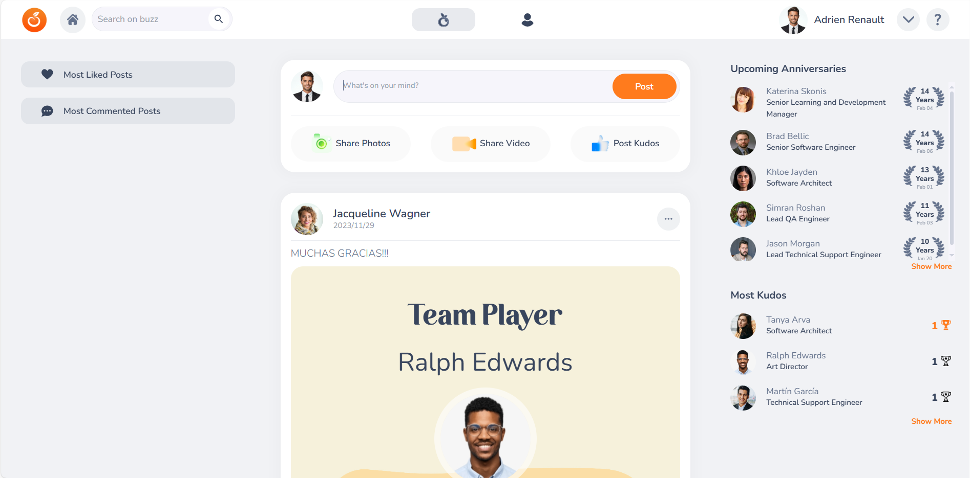

#### Image 52: Buzz

# **Reports and Analytics**

In the Reports and Analytics section, you can access reports that contain details about your subordinates, subject to the access privileges granted by your HR Administrator.

How to Create/View Reports using OrangeHRM

To view a report, navigate to the Reports and Analytics Module and select the report.

#### 

#### Image 53: Reports and Analytics

Step 1 – Select a report type and a folder.

#### 

#### Image 54: Add new report

Step 2 – Give your report a name, for this instance let’s create a report to show employees and their work location. Select the user Level for whom you want to grant access to the report.

#### 

#### Image 55: Report Name

Step 3 – Select the criteria for the report. This report needs to show the employee's work location; therefore, go to Additional Selection Criteria. Select the required fields and click Next.

#### 

#### Image 56: Selection Criteria

#### 

Step 4 – Add Display Fields. Here you can add all the fields you wish to display in the report. First, click on the Add Display Field group button and select groups. Select all the fields you wish to display by ticking the box.

Click on Save to create the report.

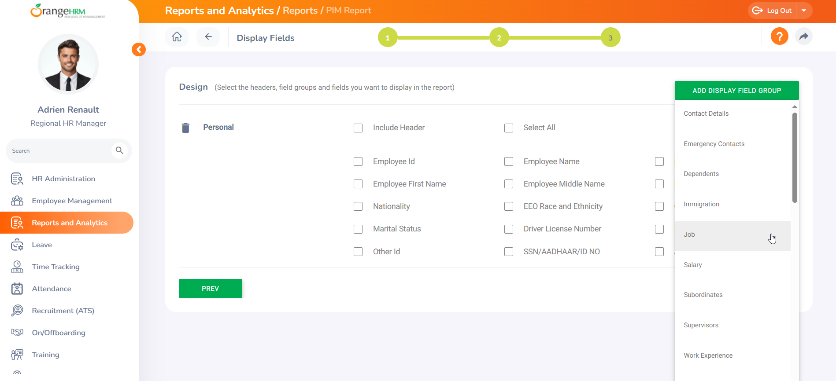

#### Image 57: Add Display Fields

The report has been generated based on the fields you have completed. You can further edit the report as needed, generate a pie chart, and download it in PDF or CSV format.

#### Image 58: Generate Report

# 

# 

# 

# 

# 

# 

# 

# 

# 

# 

# 

# 

# 

# 

# **RESOURCES**

This user guide has been designed for Toluna and for any queries use the [OrangeHRM Help Portal](https://help.orangehrm.com/hc/en-us) or for any support matters drop an email to [goldsupport@orangehrm.co](mailto:goldsupport@orangehrm.com)m

<https://help.orangehrm.com/hc/en-us>

_END_